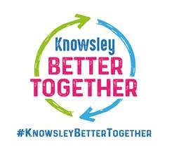

Knowsley Local Offer Website
We listened to you
You said We did

- Updated the Education tab to show that it can be found in that section

- Checked and link was going to a main page, amended to link directly to the list of providers
- Amended this form to agree

- You said you were having trouble finding the EAL service information

- You could not find the link to the nurseries/childcare
- You asked if the Early Years Registration Form could include African as an ethnicity

