Where is the little white cat?
More practice of
in, on, under, next to, behind, in front of
big and little
Seema’s English Book 5a

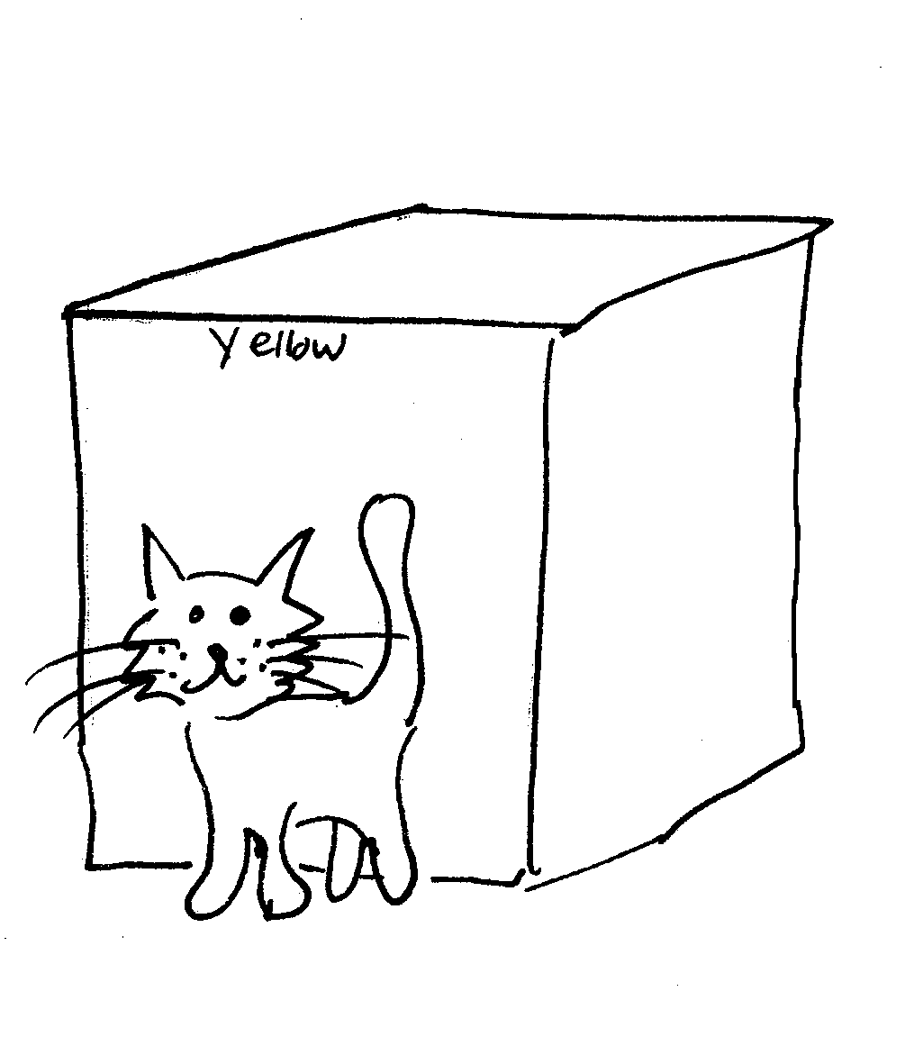
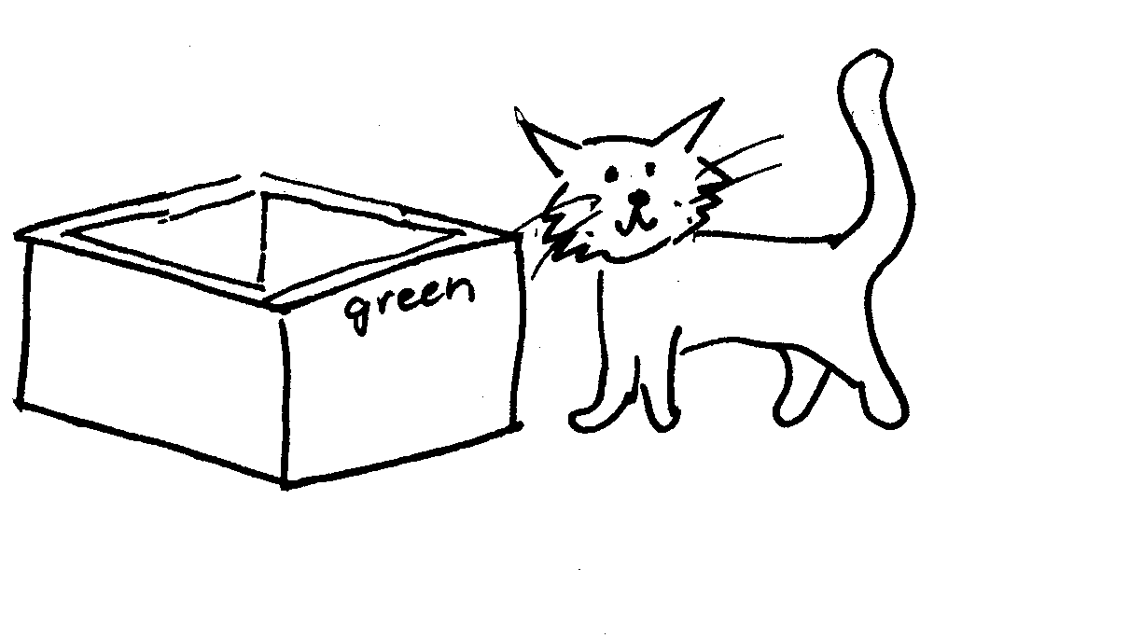

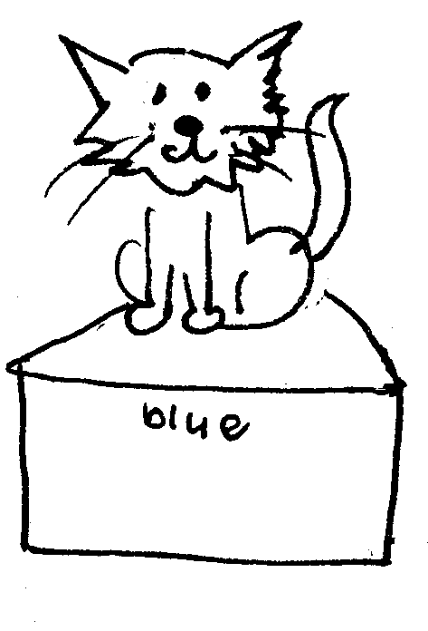

Name ………………………………………………………………

Class …………………………………………………………………

School ………………………………………………………………

Unit 5a Prepositions: in, on, under, next to, behind, in front of
Adjectives: big, little
Key question: ‘Where is the _____?’
Key response: pupils say ‘The little white cat is in the big red box’ … etc.

- Prepositions: in, on, under, next to, behind, in front of
- A six word sentence: ‘The … is … in the …’

Activities:
5.1 Check the work from Unit 5.
5.2-5.8 Sentence practice. Use Sheets 5.2 to 5.8 to give practice, as instructed on each sheet.
  - Read and draw: Practise sentences on sheet 5.9 orally for work in class.
  - Colour and write: Use 5.9 as models for pupils to copy or create their own sentences.
  - Use sentence maker 5.11a to make sentences on sheet 5.11b. Set pupils the task of writing five or more sentences before the next session.
Key expectations:
- Pupils knows more the basic prepositions.
- Pupils write a series of sentences, punctuated correctly.
Activity sheet 5.2 Where is the red ball?
Colour the pictures. Talk about the pictures. Read the sentences below and match them to the pictures.

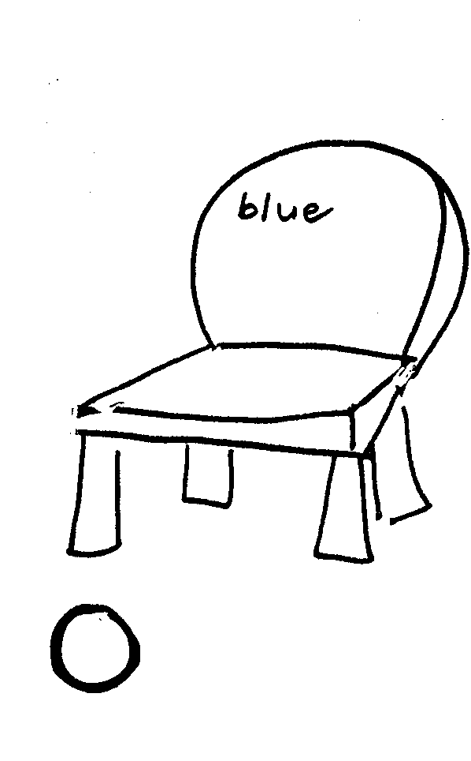 | 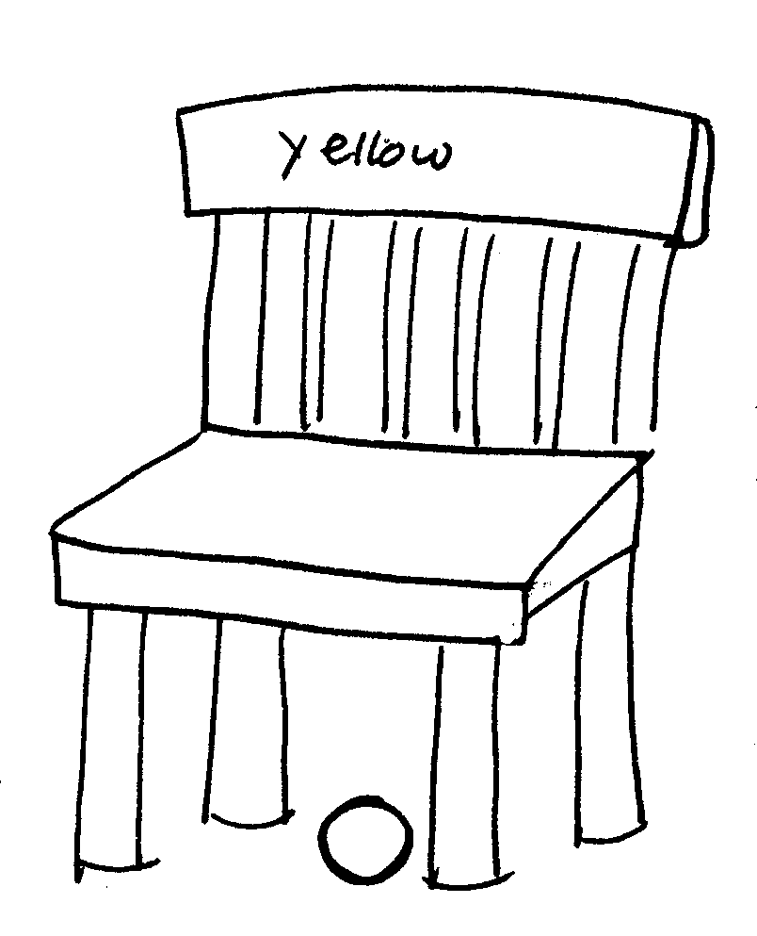
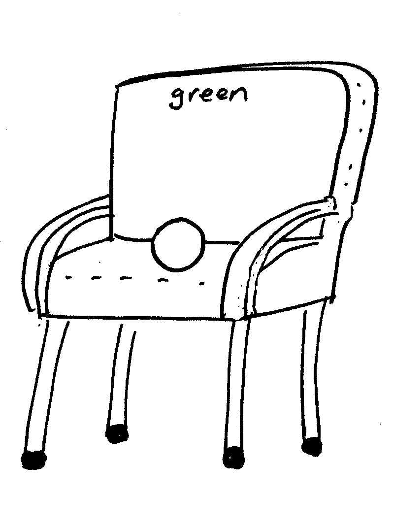 | 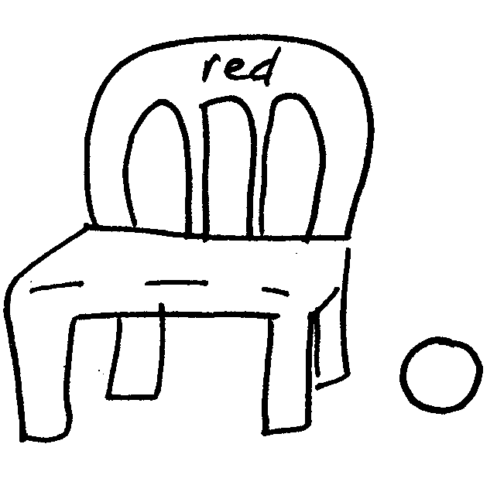

- The red ball is in front of the little blue chair.
- The red ball is under the big yellow chair.
- The red ball is on the big green chair.
- The red ball is next to the little red chair.
Activity sheet 5.3 Where is the green pencil?
Colour the pictures. Talk about the pictures. Read the sentences below and match them to the pictures.

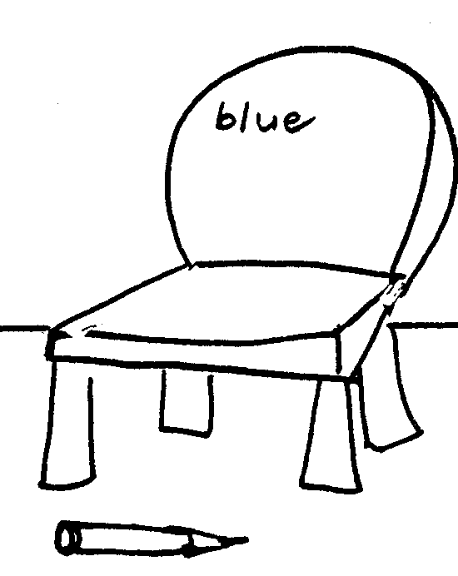 | 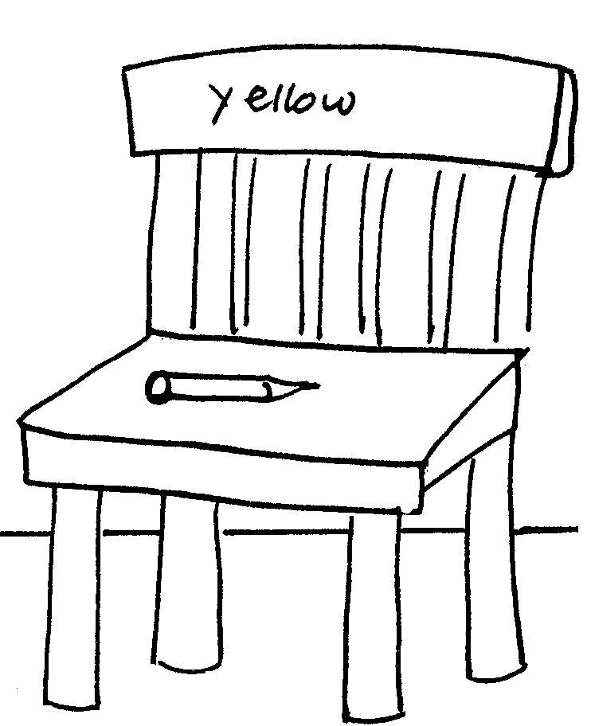
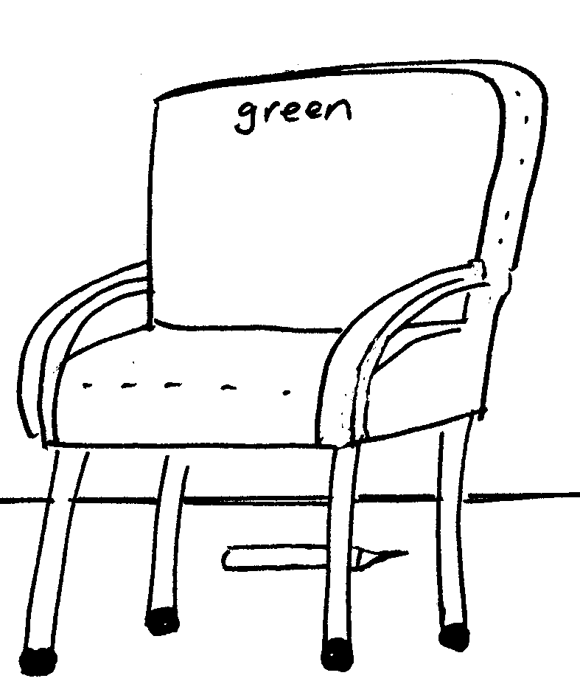 | 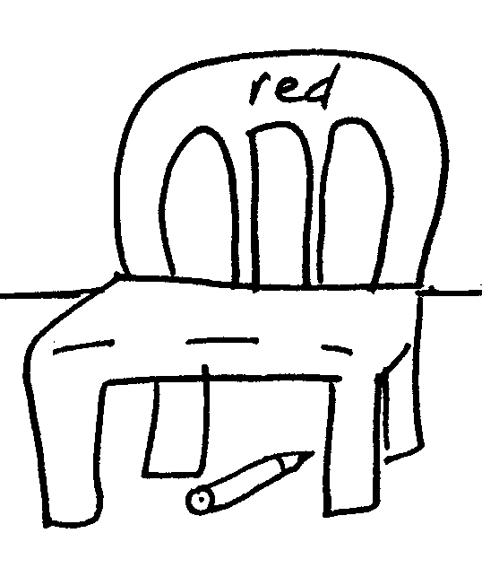

- The green pencil is in front of the little blue chair.
- The green pencil is on the big yellow chair.
- The green pencil is behind the big green chair.
- The green pencil is under the little red chair.
Activity Sheet 5.4 Where is the blue box?
Colour the pictures. Talk about the pictures. Read the sentences below and match them to the pictures.

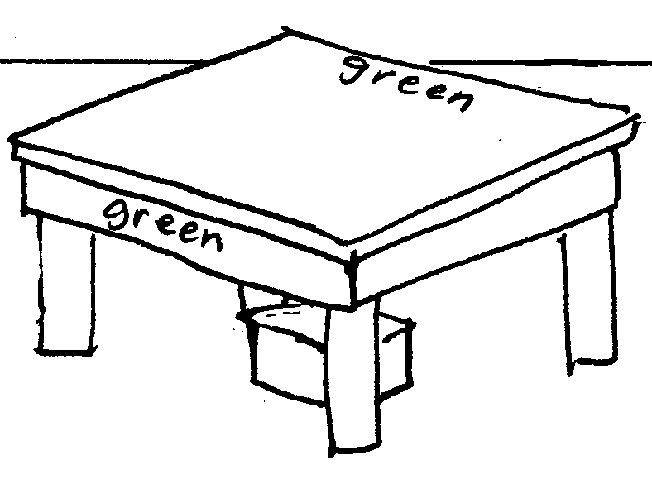 | 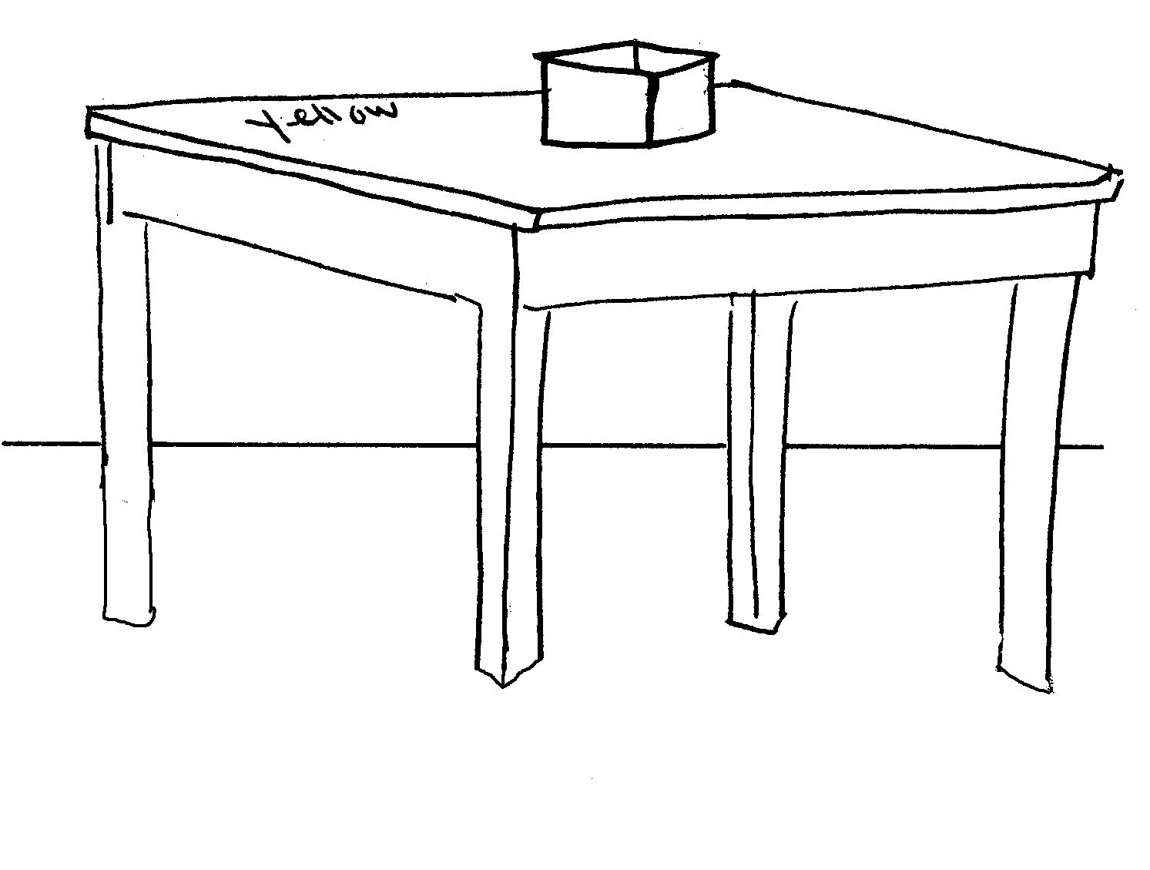
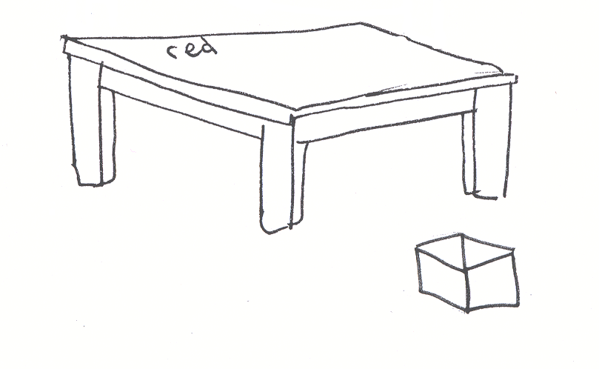 | 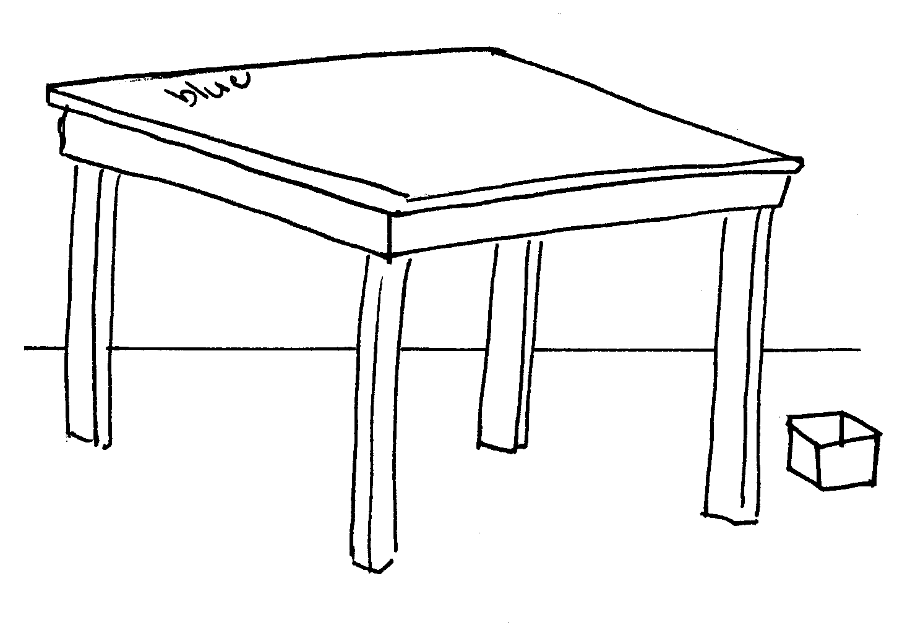

1. The blue box is under the little green table.
2. The blue box is on the big yellow table.
3. The blue box is in front of the little red table.
4. The blue box is next to the big red table.

Activity Sheet 5.5 Where is the yellow flower?

Colour the pictures. Talk about the pictures. Read the sentences below and match them to the pictures.

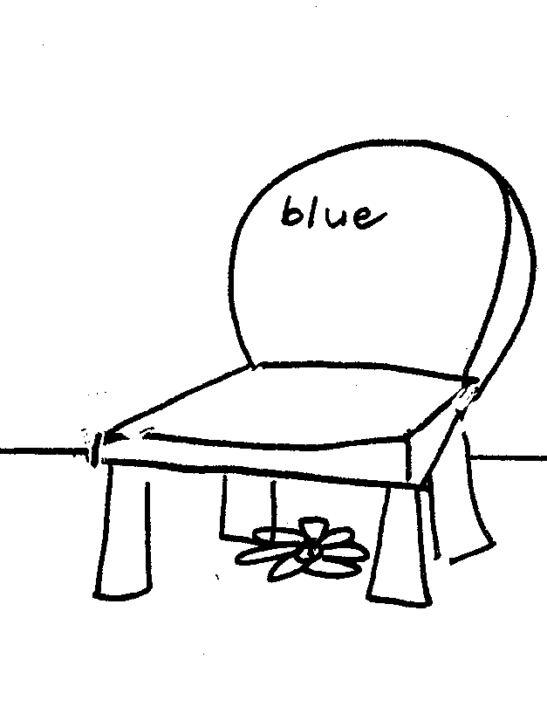 | 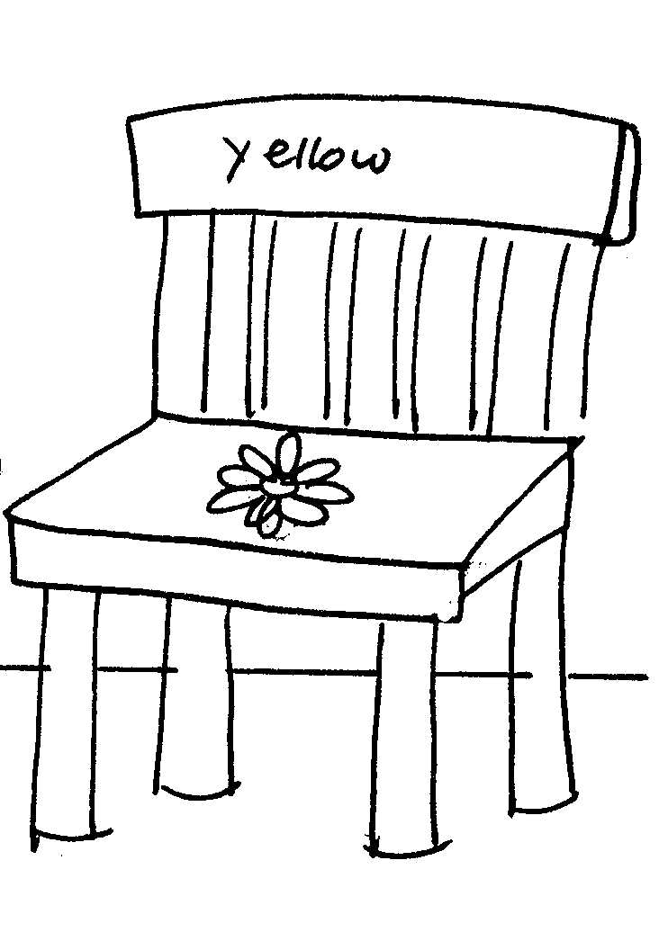
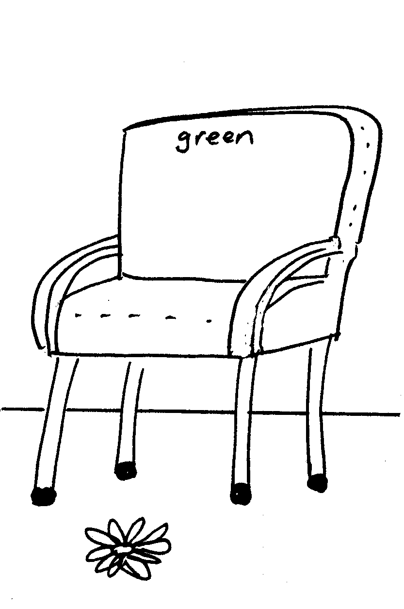 | 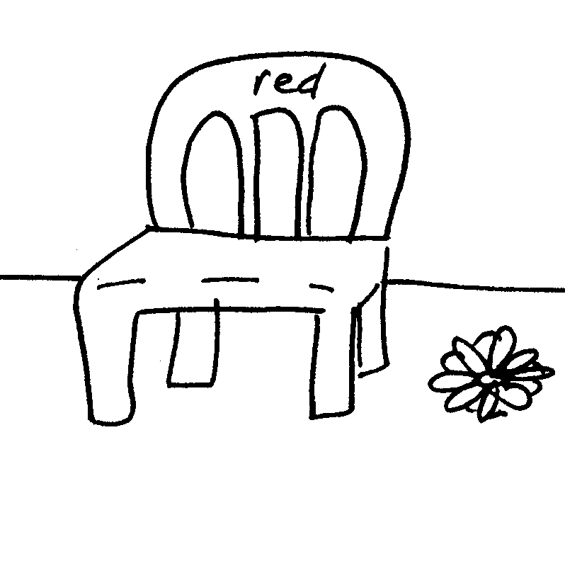

- The yellow flower is under the little blue chair.
- The yellow flower is on the big yellow chair.
- The yellow flower is in front of the big green chair.
- The yellow flower is next to the little red chair.
Activity Sheet 5.6 Where is the little boy?

Colour the pictures. Talk about the pictures. Read the sentences below and match them to the pictures.

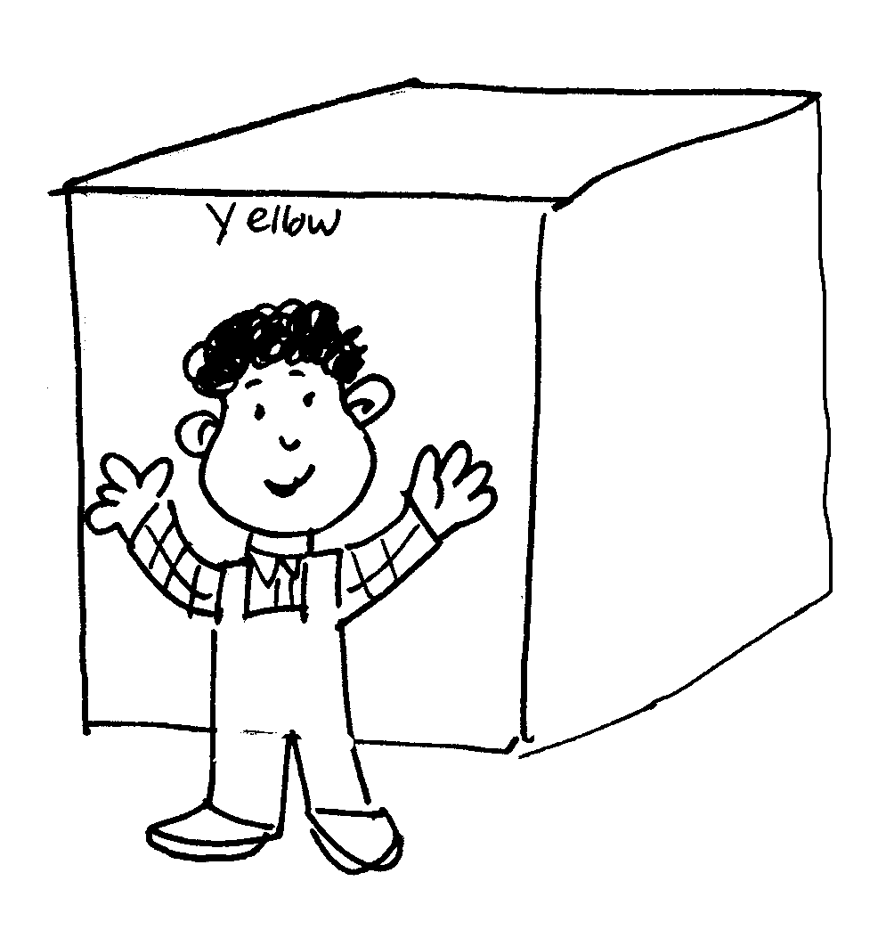 | 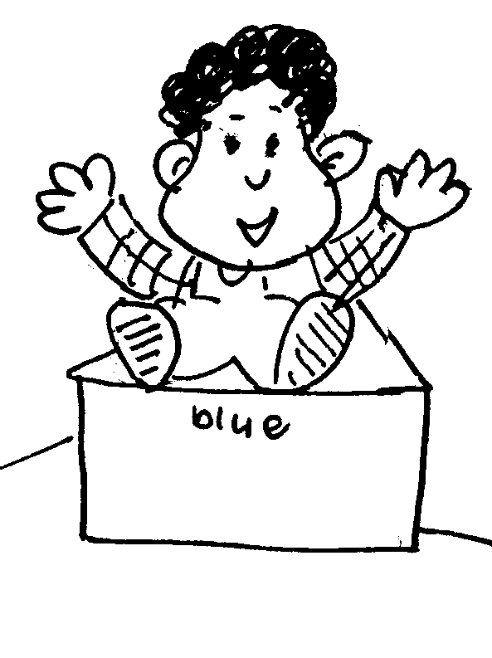
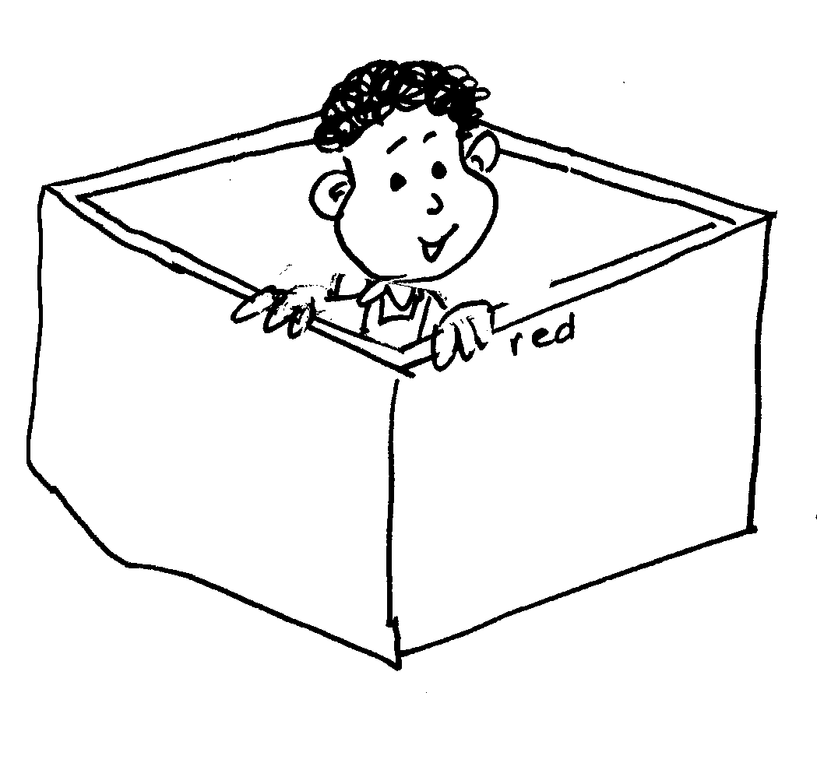 | 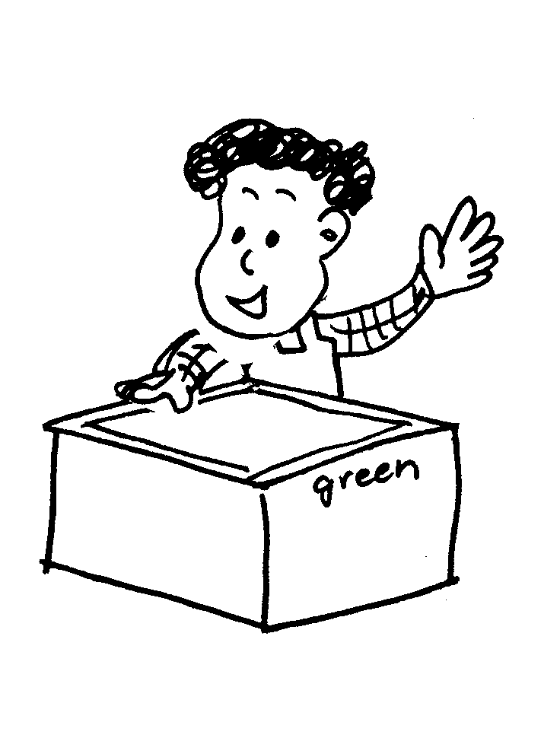

- The little boy is in front of the big yellow box.
- The little boy is on the little blue box.
- The little boy is in the big red box.
4. The little boy is behind the little green box.

Activity Sheet 5.7 Where is the little yellow dog

Colour the pictures. Talk about the pictures. Read the sentences below and match them to the pictures.

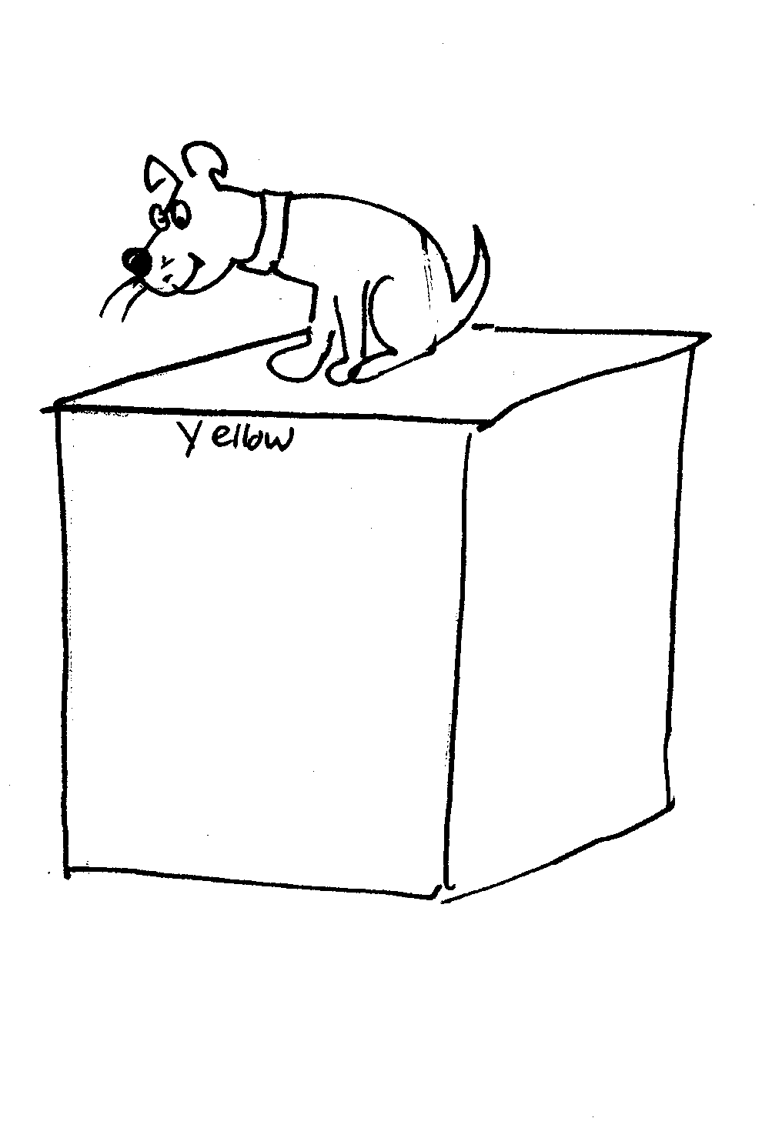 | 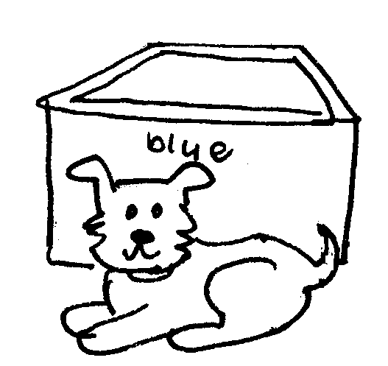
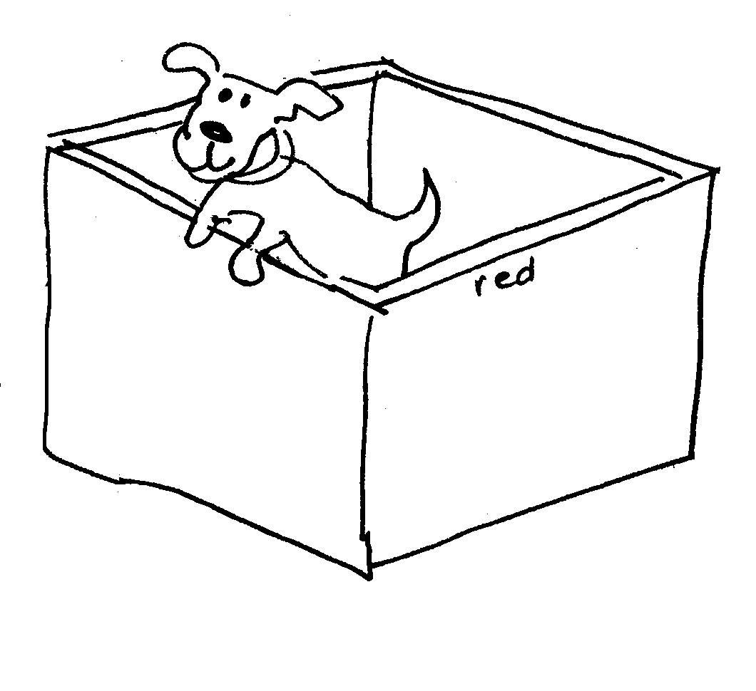 | 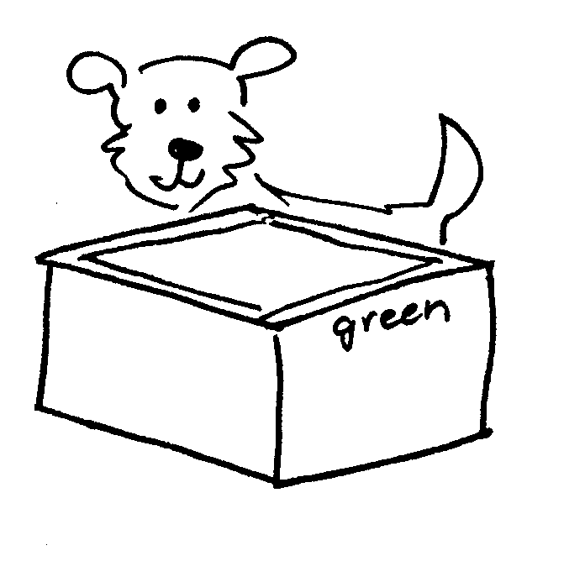

- The little yellow dog is on the big yellow box.
- The little yellow dog is in front of the little blue box.
- The little yellow dog is in the big red box.
4. The little yellow dog is behind the little green box.

Activity Sheet 5.8 Where is the little white cat?

Colour the pictures. Talk about the pictures. Read the sentences below and match them to the pictures.

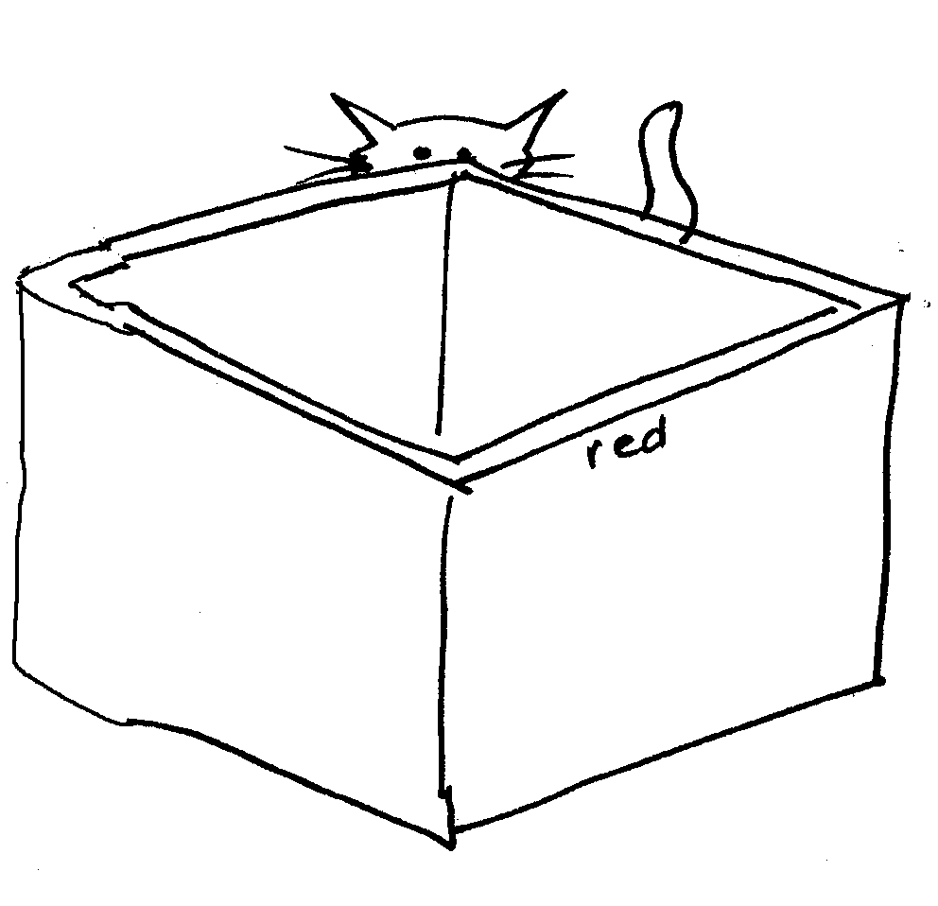

- The little white cat is in front of the big yellow box.
- The little white cat is on the little blue box.
- The little white cat is behind the big red box.
4. The little white cat is next to the little green box.

Activity 5.9 Read and draw

The green pencil is under the little yellow table. | The red ball is on the big red chair.
The little white cat is next to the big green table. | The little boy is behind the orange chair.
The yellow flower in on the little red table. | The little white cat is in the purple box.
The little yellow dog is in the green bin. | The blue fish cat is next to the big white cat.

Activity 5.10 Colour and write sheet

1 ……………………………………………………………………………………………….

2 ………………………………………………………………………………………………

3 ………………………………………………………………………………………………

4 ………………………………………………………………………………………………

5 ..................................................................................................

6……………………………………………………………………………………………….

7………………………………………………………………………………………………

8 ………………………………………………………………………………………………

9 ………………………………………………………………………………………………

10..................................................................................................

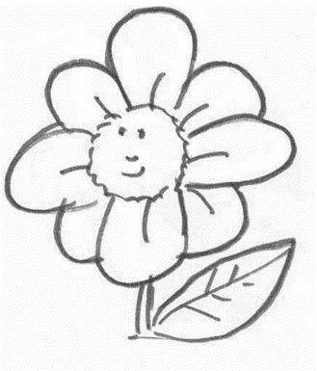
5.11a Sentence maker

The | brown | cat | is | in | the | little | black | box.
 | yellow | dog |  | on |  | big | white | table.
 | white | flower |  | under |  |  | yellow | chair.
 | blue | pencil |  | next to |  |  | blue
 | black |  |  | behind |  |  | orange
 |  |  | in | front | of
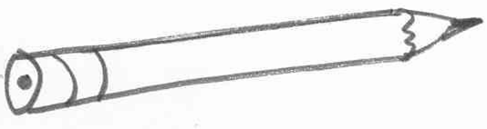
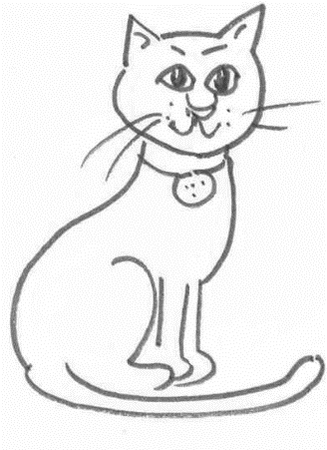
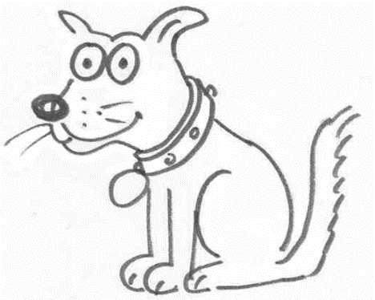
5.11b Writing sheet

Write about it

……………………………………………………………………………………....................................................................................................................................................................................................................................................................................................................................................................................................................................................

