The girl is happy.
Happy and Sad
Seema’s English Book 4

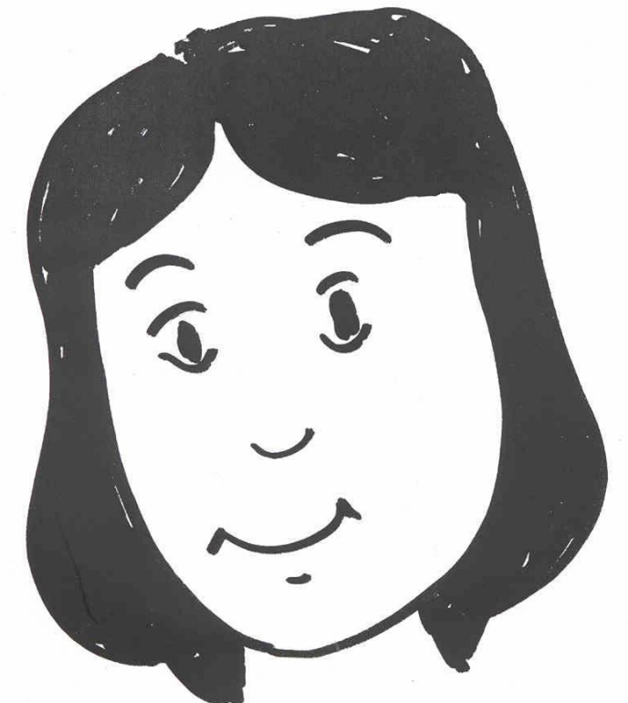

Name ………………………………………………………………

Class …………………………………………………………………

School ………………………………………………………………
Unit 4 Happy and Sad
Key question: ‘How is the?’ etc
Key response: pupil says ‘The boy is sad’ … etc.

- Adjectives: happy, sad.
- Nouns: man, woman, boy, girl.
- A four word sentence: ‘The … is…’

Activities:
4.1 Check the sentence and colour work from Unit 3.
4.2 Say the words: Mime the feeling happy/sad. Ask pupils to mime happy. Point to the pictures on 4.3 and say ‘happy, sad, man, woman …’ etc. Ask pupils to repeat each time.
  - Read the words: Cut out the words and pictures on sheet 4.2 and 4.3. Lay them out on the table and match them.
  - Read the sentence: Read the sentences on sheet 4.4 and draw matching pictures.
  - Say a sentence: Use sentence maker 4.5 to make up new sentences. Point to each word as you make the sentence. Point to the full stop at the end. Ask ‘How is the woman?’, model answer by saying, ‘The woman is happy full stop’. Ask the pupil to say the sentence, and to add the full stop orally. Ensure pupils use the capital and full stops.
  - Write a sentence: use sentence maker 4.5 and writing sheet 4.6 to make a sentence. Set pupils the task of writing five or more sentences before the next session.

Key expectations:
- Pupils speak and write in complete sentences.
- Pupils know happy and sad.
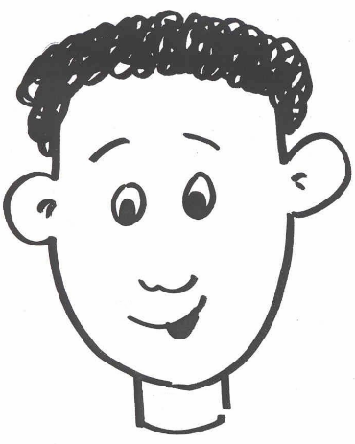 | 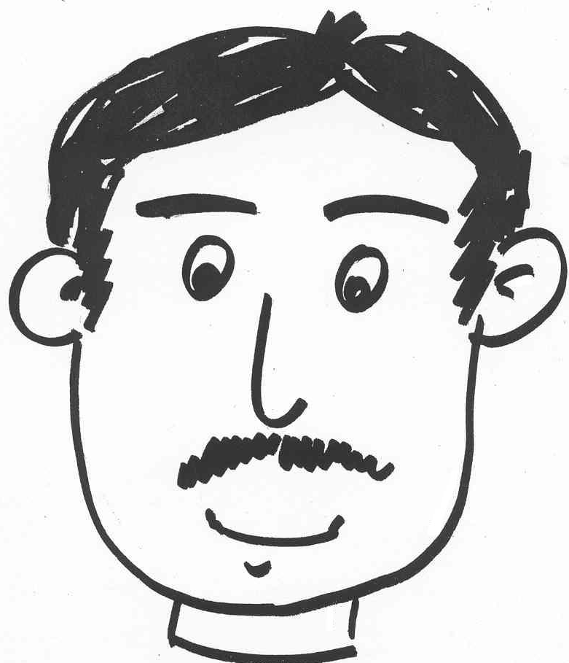
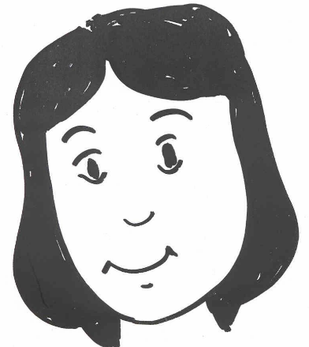 | 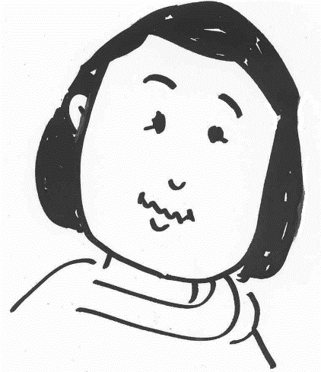
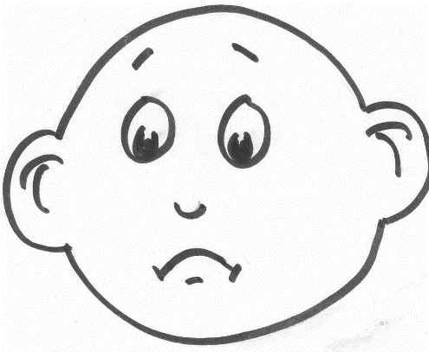 | 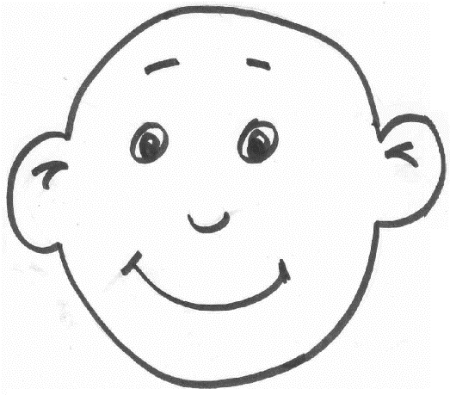
Pictures for activity 4.2

Words for activity 4.3
a boy | a woman
a girl | a man
sad | happy

Read and draw activity 4.4
The boy is happy. | The man is sad.
The cat is sad. | The girl is happy.
The woman is happy. | The man is sad.
The girl is sad. | The woman is sad.

Sentence maker 4.5

 | man
 | girl |  | happy.
The | boy | is | sad.
 | woman
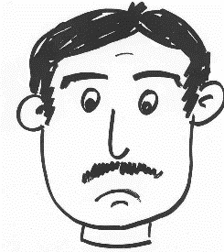
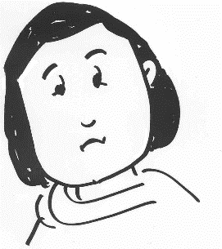
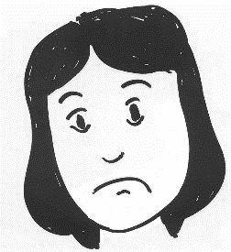

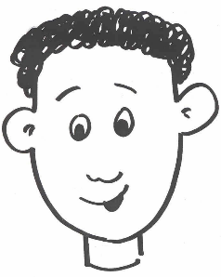
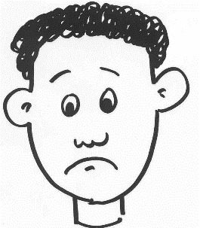
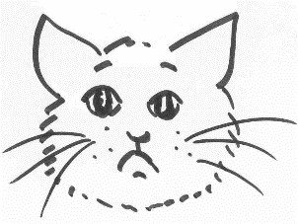
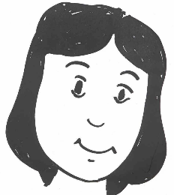
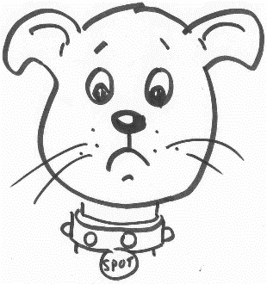
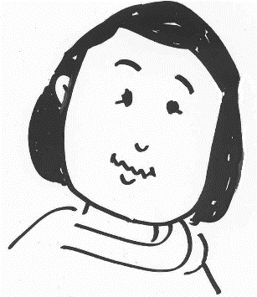
Writing sheet 4.6

Write about it

……………………………………………………………………………………....................................................................................................................................................................................................................................................................................................................................................................................................................................................
…………………………………………………………………………………………………………………………………………………………………………

