Seema’s English Book 1

Name ………………………………………………………………

Class …………………………………………………………………

School ………………………………………………………………
Unit 1 Naming an object

Key instruction: ‘show me a …’
Key response: pupil points and says ‘a book’

- 10 classroom nouns; a pencil, a book, a chair, a ruler, a bin, a brush, a table, a door, window, a rubber

Activities:
  - Name real objects. Point to the relevant objects around the classroom. Say ‘a chair, a table, a book …’, take care to use the indefinite article (the word a or an) each time. Ask pupil to repeat each time. Make sure he or she uses the article a or an. Say ‘show me a …’ and get pupil to point and name the object, using a or an each time.
  - Name the pictures. Cut out the pictures on sheet 1.2, lay them out on the table. Pick up each card naming it ‘a book, a table …’, say ‘show me a table’. Get the pupil to point and say ‘a table’.
  - Read the words. Cut out the words and show how to match the words to the pictures. Then check that the pupil can read each word.
  - Write the words. Set the work for independent and supported practice. Give pupil sheet 1.4 and demonstrate the task of writing the word with the a or an article by each picture. Ask the pupil to do number 1 of the writing task to ensure understanding.

Key expectations:
- Pupils use the word a before saying each noun.
- Pupils begin to read and write the words.
Cut and match sheet 1.2

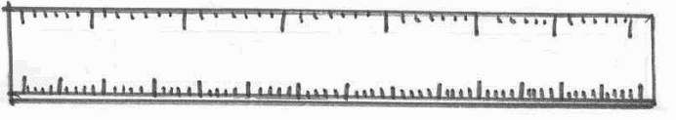 | 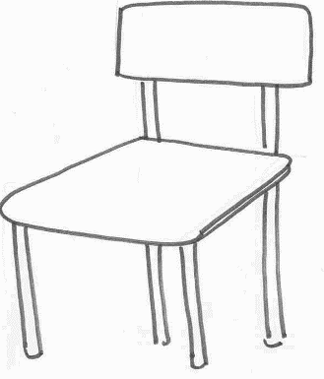
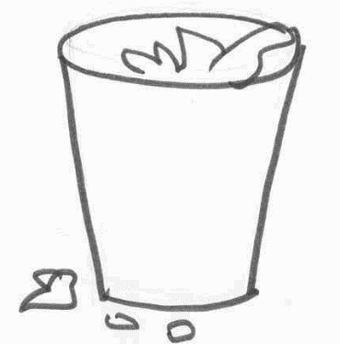 | 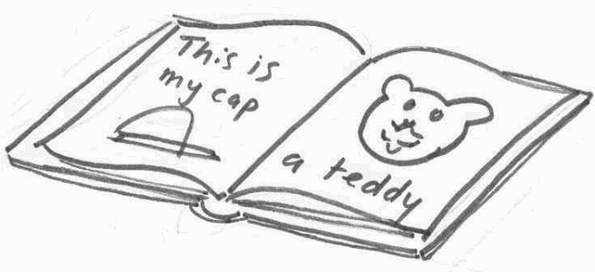
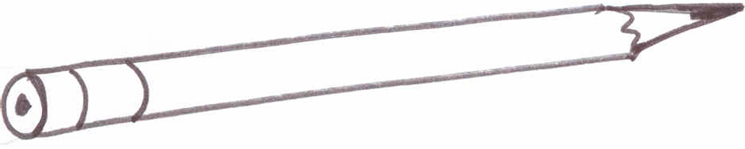 | 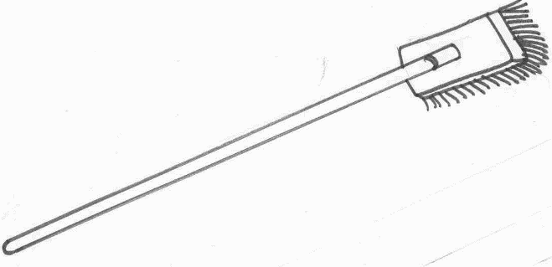
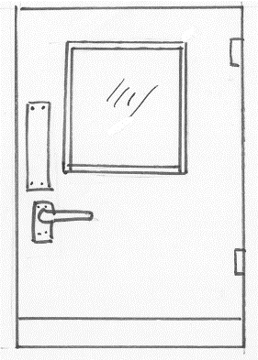 | 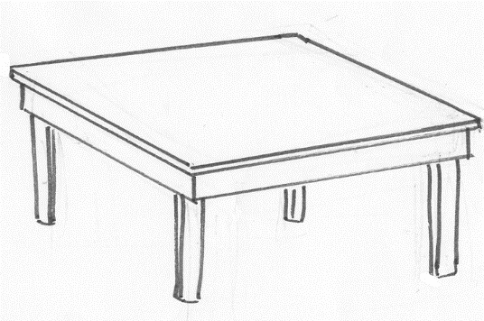
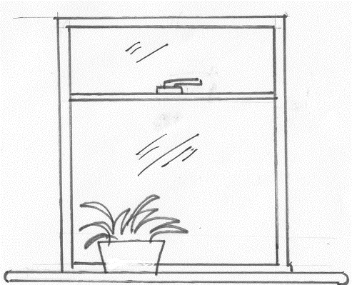

Cut and match sheet 1.3

a ruler | a chair
a bin | a book
a pencil | a door
a brush | a rubber
a table | a window
Colour and write sheet 1.4

1 ……………………………………………………

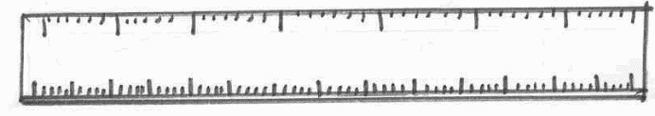
2……………………………………………………

3……………………………………………………

4 ……………………………………………………

5……………………………………………………

Colour and write sheet 1.4

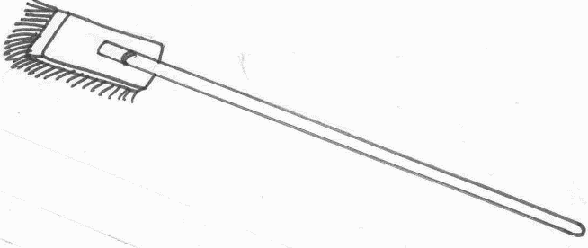

6 ……………………………………………………

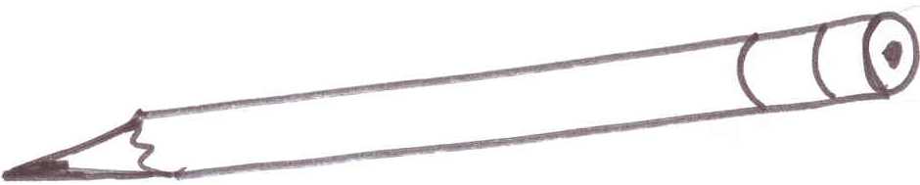

7……………………………………………………

8……………………………………………………

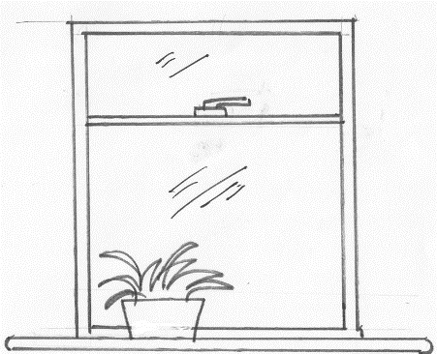

9 ……………………………………………………

10……………………………………………………

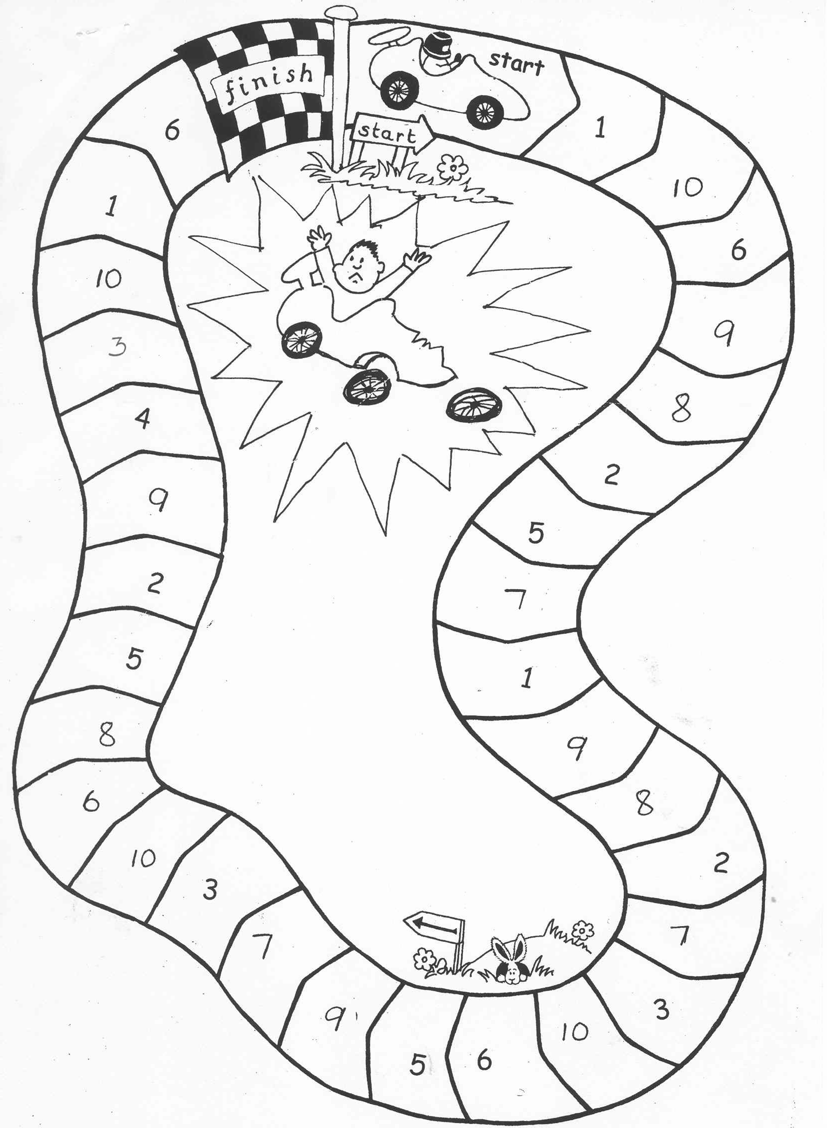
9
1
3
10
6
8
5
2
9
4
7
5
2
7
8
2
7
3
10
9
6
5
1
3
10
8
9
6
10
6
1

Car Chase

- This game is ideal for further practice with peers and with parents. It can be played with any new words. Number the cards 1-10 on the back.
- Spread all the cards (numbers up) on the table.
- Player 1 throws a dice and calls the number he or she lands on. Player 2 picks up the card with that number on, and asks player 1 to say the word. Ask more able pupils to write the word.
- If correct, player 1 stays on that square.
- If incorrect, player 1 stays on that square, but places the card on the crashed car with the word up to say or spell before his of her next throw.
- First one home wins.

The game can be coloured and laminated for future use.

