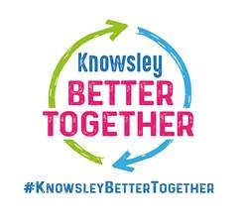

Knowsley Local Offer Website
We listened to you
You said We did

- Contacted Health and they supplied a newer poster with updated information which was added to the website
- Emailed and let enquirer know about the Places to Go website and how the activities were normally listed there as well, broken down into ages (unfortunately with Covid not much running), also advised they contact provider with specific enquiry, and they would try to accommodate.

- You said there were no up-to-date referral forms or email address for NDPathway
- You were unhappy with how the SEND activities were listed on the same page and didn’t mention types of SEND they worked with.

