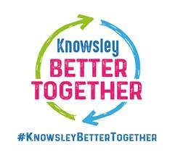

Knowsley Local Offer Website
We listened to you
You said We did

- We made the links to the SEN Team more obvious by adding more keywords for the search option to locate. We also added the full wording for Special Education Team

- You were finding it difficult locating “How to apply for EHCP”
- Problems finding Special Educational Teams page

