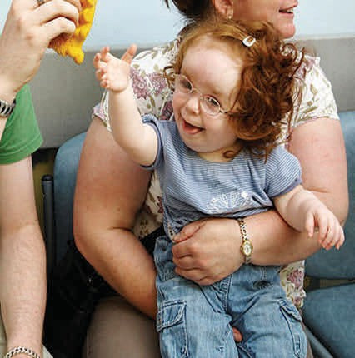
Who decides? What happens next?

The health assessor will make a case to the CCG, who decide based on the evidence, and the recommendation, if the child or young person has a continuing care need.

A decision is usually made 6-8 weeks from referral.

Depending on the decision, a package of care is then agreed; some of this care may be provided through existing services; some may need to be specially arranged.

The CCG will keep the package of care under regular review to ensure the developing child or young person’s needs continue to be supported.

A child or young person’s eligibility for continuing care may change as their needs change.

Find information about Continuing Care
on the Local Offer website

Knowsley Local Offer

Continuing Care Team

knccg.chcteam@nhs.net



Disabled and Ill Child Services Team
2E60, Department of Health, Quarry House, Quarry Hill, Leeds LS2 7UE

Children and young people’s continuing care

A brief guide for young people and parents

January 2016

What is continuing care?

Some children and young people (up to age 18), may have very complex health needs.

These may be the result of:

• congenital conditions
• long-term or life-limiting conditions
• disability
• serious illness or injury

Children with such complex needs may need additional health support to that which is routinely available from GP practices, hospitals or in the community.

This additional package of care is called continuing care. The clinical commissioning group, which is responsible for arranging for health services locally, has responsibility for assessing children and young people to see if they need a package of continuing care.
Who is eligible?



Any child or young person up to their 18th birthday who has a complex health need may be eligible.

When a young person reaches 18, the adult NHS Continuing Healthcare arrangements apply.

There are significant differences between children and young people’s continuing care and NHS Continuing Healthcare for adults. Although a child or young person may be in receipt of a package of continuing care, they may not be eligible for NHS Continuing Healthcare as an adult. The CCG will assess any young person in receipt of continuing care when they are aged 16-17, to see if they are likely to be eligible for NHS Continuing Healthcare when they turn 18.
How can we access continuing care?

A referral can be made by any health
professional or carer who feels a continuing care package may be required.

When a child or young person is
referred for an assessment, the CCG will first check if they are likely to need a full assessment.

A health assessor will then collect evidence of the child’s needs, drawing on the advice of health and care professionals. A national framework provides guidance, and a set of categories of needs to support decisions on whether or not a child has a continuing care need.

An important part of the assessment is to capture the preferences of the child or young person and their family.

The assessment will look at the current care being provided but a decision on whether or not a child or young person has a continuing care need is based on the nature of their needs, rather that the care available, or whether or not they have a particular condition.

