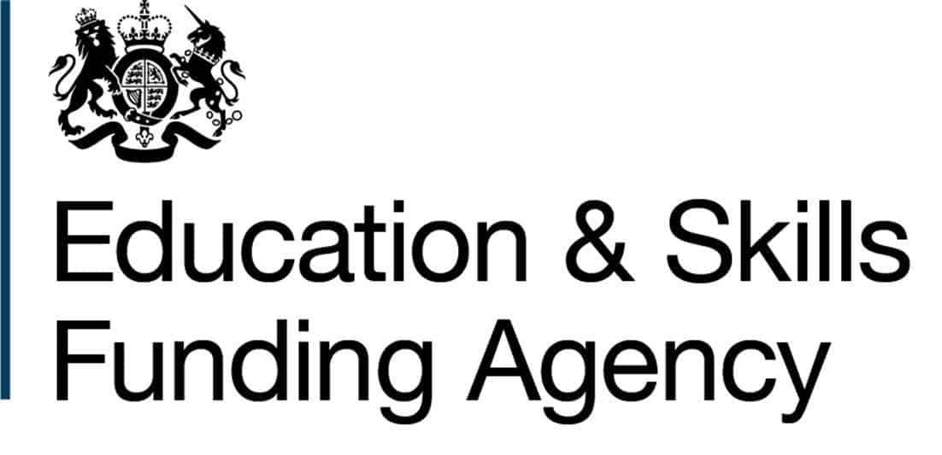
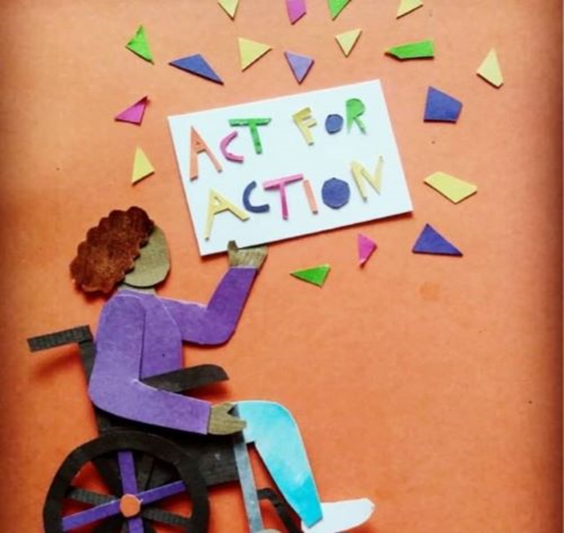


Opening October 2022
INTERESTED? Want to know about prices /view facilities?
Contact:
Louise @act-for-action.co.uk
or
Helen@act-for-action.co.uk

0151 923 1962
ACT FOR ACTION CIC
Act for Action
Are opening a Performing Arts Training Centre for Disabled Adults

Where: Unit 5, Puma Court, King’s Business Park, Prescot L34 1PJ

Accredited courses at the appropriate level!
Highly qualified and experienced staff!
Multi-sensory and FUN
- English
- Maths
- Employability skills
- Life skills
- CEIAG
- Performing Arts
- Supported employment opportunities in the arts sector

Day rates : £80 - £90

