



Knowsley Wraparound

TESS Guide


Aspect 2
The Environment

“There are three teachers of children: adults, other children, and their physical environment.”
- LORIS MALAGUZZI


The Typical
Experience
Score Sheets (TESS)

A Guide To
Grading Scale – designed to promote reflection on key areas of the provision.
Consider the 1|2|3 format as a ladder for demonstrating progression (e.g. you may grade Term One a 1 and by the start of Term Three you may grade yourself a 3)
As your provision starts to feel established or evolves over time you may naturally feel that you have progressed through the ‘Areas’.
You may notice as children/team members settle some indicators will improve.
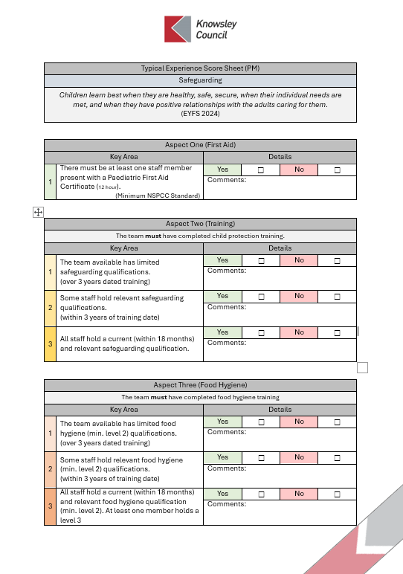
TESS
If you are finding yourself consistently highlighting 1s & 2s or have found that a change you have made has led to lower results; it may be time to consider changing aspects of the provision or even feeding these into supervisions to support CPD and access to Knowsley led courses e.g. Safeguarding Training
A simplified Yes | No format should allow for speed of completion.
The comments section is an opportunity to list evidence or a place to jot notes for ideas for future development.
Only tick Yes for one area 1|2|3 if this is evident in your practice/provision.
Don’t be afraid to grade low, be honest and use this as a starting point to push quality.
Don’t be afraid to grade high, if you have the evidence in practice this form can be used to support your Ofsted preparation.

Typical Experience Score Sheet (PM)
The Environment
Creating spaces that are appealing, continually available and familiar to young children enables deeper learning – as children return to, repeat and extend their ideas over time. This promotes mastery behaviour as children are introduced to and supported with the use of carefully selected high-quality resources.
(Early Excellence 2024)

Experience One (Awareness)
Key Area |  | Details
1 | The team have limited to no knowledge of the impact of the Wraparound environment. | Yes | ☐ | No | ☐
1 |  | Comments:
2 | The team have some understanding of the impact of the Wraparound environment but this is not commonly discussed or considered. | Yes | ☐ | No | ☐
2 |  | Comments:
3 | The team have a strong knowledge of the value of a high quality Wraparound environment and can present this confidently | Yes | ☐ | No | ☐
3 |  | Comments:

Experience Two (Training)
Key Area |  | Details
1 | The team available has not completed training on the learning environment.  (over 3 years dated training) | Yes | ☐ | No | ☐
1 |  | Comments:
2 | Some staff have completed the Wraparound environment training.  (within 2 years of training date) | Yes | ☐ | No | ☐
2 |  | Comments:
3 | All staff have attended Sthe Wraparound environment training recently (within 18 months). | Yes | ☐ | No | ☐
3 |  | Comments:

Experience Three (Reviewing Spaces)
Key Area |  | Details
1 | The team do not notice the environment in which they operate. Reviews of the provision are irregular and linear, ignoring the opportunities for external insight. | Yes | ☐ | No | ☐
1 |  | Comments:
2 | The team utilise a wide array of tools to regularly review the environment, including the voice of the child in decision making. | Yes | ☐ | No | ☐
2 |  | Comments:

Experience Four (Updating The Environment)
Key Area |  | Details
1 | The space does not change over time. The team are unsure of how to adapt the space to new cohorts or changes in seasons / topics. | Yes | ☐ | No | ☐
1 |  | Comments:
2 | The space is adaptable, changing and adapting to the needs of the children accessing the provision. A wide variety of concepts are considered when updating the environment including seasons, volume and furniture size. | Yes | ☐ | No | ☐
2 |  | Comments:

Experience Five (Volume & Sound Pollution)
Key Area |  | Details
1 | Activities all take place in the same space. There is a high volume often distracting and disrupting quieter children and activities. | Yes | ☐ | No | ☐
1 |  | Comments:
2 | There is a careful blend of spaces designed for high volume activities and quieter, communication friendly, cosy spaces. | Yes | ☐ | No | ☐
2 |  | Comments:

Experience Six (Displays)
Key Area |  | Details
1 | Displays are adult-directed and outcome based. Children do not actively contribute, often completing templates or conveyor belt style hand paintings. | Yes |  | ☐ |  | No |  | ☐
1 |  | Comments:
2 | Displays on all eye levels are purposeful, inviting curiosity, conversations and making children’s contributions feel valued. | Yes |  | ☐ |  | No |  | ☐
2 |  | Comments:
Experience Seven (Inclusive, Ambitious Imagery)
Key Area |  |  | Details
1 | There is little to no photos around the space. Those that are available do not compel curiosity or conversation. Imagery is not inclusive and has the potential to alienate some children accessing the Wraparound provision. |  | Yes |  | ☐ |  | No | ☐
1 |  |  | Comments:
2 | Exciting, ambitious photos encourage curiosity and make areas more inviting. Imagery is inclusive, reflecting the wide array of children and families accessing the provision. |  | Yes |  | ☐ |  | No | ☐
2 |  |  | Comments:

Experience Eight (The Outdoor Space)
Key Area |  | Details
1 | Access to the space is inconsistent, the outdoor space is not considered during the planning of the provision. The team do not display the same confidence in support learning outdoors as they do indoors. | Yes | ☐ | No | ☐
1 |  | Comments:
2 | The outdoor provision is an extension of the indoors. The outdoor space is actively considered in planning for activities and events. There are regular opportunities for all to interact with and explore the outdoor space. Staff feel confident in support engagement and learning in the outdoor provision and what makes it unique compared to the indoor environment. | Yes | ☐ | No | ☐
2 |  | Comments:

Experience Nine (Thinking Sustainability)
Key Area |  | Details
1 | There is little to no consideration for the impact of the equipment used. The team and children are unaware of the impact of the equipment, there is a disposable culture. | Yes | ☐ | No | ☐
1 |  | Comments:
2 | The team consider the impact of the resources and equipment on the environment. Sustainability is at the centre of planning process with children actively aware of their impact. | Yes | ☐ | No | ☐
2 |  | Comments:

Experience Ten (Awe & Wonder)
Key Area |  | Details
1 | The team miss opportunities to create awe and wonder with their children. Imagery and the environment do not naturally provoke inquiry and curiosity, | Yes | ☐ | No | ☐
1 |  | Comments:
2 | The team recognise and act on opportunities to explore awe and wonder moments. Staff and children regularly engage in nature walks, star/cloud gazing, celebration of cultural events, collective play and dance, child led artistic expression and discussions about the people and world around them | Yes | ☐ | No | ☐
2 |  | Comments:

Experience Eleven (Child Contribution)
Key Area |  | Details
1 | The wraparound provision is pre planned and adult led. | Yes | ☐ | No | ☐
1 | The wraparound provision is pre planned and adult led. | Comments:
2 | Children are actively consulted with the environment reflecting their likes, dislikes, learning styles and schemas. There are regular opportunities for children to voice their opinion on the provision and the team are sensitive to the unspoken voice of their children e.g. exes. | Yes | ☐ | No | ☐
2 |  | Comments:



