



Knowsley Wraparound

TESS Guide


Aspect 3
Staff:Child Interactions

“Every child deserves a champion – an adult who understands the power of connection and insists they become the best they can possibly be.”
- RITA PIERSON


The Typical
Experience
Score Sheets (TESS)

A Guide To
Grading Scale – designed to promote reflection on key areas of the provision.
Consider the 1|2|3 format as a ladder for demonstrating progression (e.g. you may grade Term One a 1 and by the start of Term Three you may grade yourself a 3)
As your provision starts to feel established or evolves over time you may naturally feel that you have progressed through the ‘Areas’.
You may notice as children/team members settle some indicators will improve.
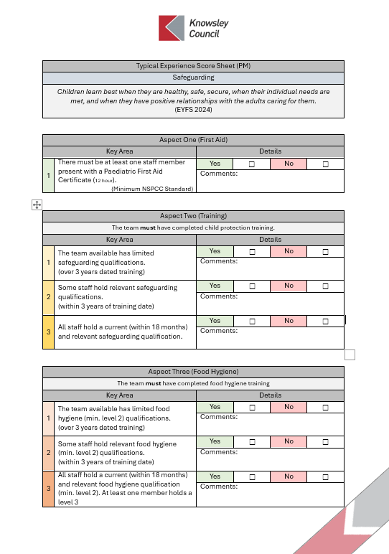
TESS
If you are finding yourself consistently highlighting 1s & 2s or have found that a change you have made has led to lower results; it may be time to consider changing aspects of the provision or even feeding these into supervisions to support CPD and access to Knowsley led courses e.g. Safeguarding Training
A simplified Yes | No format should allow for speed of completion.
The comments section is an opportunity to list evidence or a place to jot notes for ideas for future development.
Only tick Yes for one area 1|2|3 if this is evident in your practice/provision.
Don’t be afraid to grade low, be honest and use this as a starting point to push quality.
Don’t be afraid to grade high, if you have the evidence in practice this form can be used to support your Ofsted preparation.

Typical Experience Score Sheet (PM)
Staff:Child Interactions
Research shows that good interactions between adults and children make a big difference to how well communication and language skills develop. Children benefit from being with responsive and enthusiastic adults who show interest in talking with them.
(DfE,2024)

Experience One (Awareness)
Key Area |  | Details
1 | The team have limited to no knowledge of the impact of ‘Staff:Child Interactions’ | Yes | ☐ | No | ☐
1 |  | Comments:
2 | The team have some understanding of the value of positive ‘Staff:Child Interactions’ but this is not commonly discussed or considered. | Yes | ☐ | No | ☐
2 |  | Comments:
3 | The team have a strong knowledge of the value of positive ‘Staff:Child Interactions’ and how this applies to their practice and provision. | Yes | ☐ | No | ☐
3 |  | Comments:

Experience Two (Training)
Key Area |  | Details
1 | The team available has not completed training on Staff:Child Interactions.  (over 3 years dated training) | Yes | ☐ | No | ☐
1 |  | Comments:
2 | Some staff have completed Staff:Child Interactions training.  (within 2 years of training date) | Yes | ☐ | No | ☐
2 |  | Comments:
3 | All staff have attended Staff:Child Interactions training recently (within 18 months). | Yes | ☐ | No | ☐
3 |  | Comments:

Experience Three (Key Person)
Key Area |  | Details
1 | Children are not assigned to any team member in particular, with no official point of reference for children or families | Yes | ☐ | No | ☐
1 |  | Comments:
2 | Each child is assigned a key person who acts as a key point of reference for families and children. They are the child’s primary source of reassurance and security. | Yes | ☐ | No | ☐
2 |  | Comments:

Experience Four (Group Involvement)
Key Area |  | Details
1 | The team engage in groups but some voices are prioritised based off of personalities or volume. | Yes | ☐ | No | ☐
1 |  | Comments:
2 | The team are capable of adjusting to different groups, balancing and reflecting the language levels of the children involved. | Yes | ☐ | No | ☐
2 |  | Comments:

Experience Five (Supporting Positive Behaviour)
Key Area |  | Details
1 | There are inconsistencies across the team when supporting behaviour. These interactions may cause behaviours to escalate or fail to address the cause of the conflict | Yes | ☐ | No | ☐
1 |  | Comments:
2 | There is a consistent and supportive approach to supporting positive behaviour across the team. This may occasionally be adapted to suit specific children but this adaptation is inclusive rather than isolating. | Yes | ☐ | No | ☐
2 |  | Comments:

Experience Six (Building Independence)
Key Area |  | Details
1 | Spaces, routines and staff behaviour does not promote independence; children are reliant on adults for direction. | Yes |  | ☐ |  | No |  | ☐
1 |  | Comments:
2 | The team actively promote independence, offering opportunities for self-led tasks, dressing and child directed activities. | Yes |  | ☐ |  | No |  | ☐
2 |  | Comments:
Experience Seven (Supporting Transitions)
Key Area |  |  | Details
1 | All children are expected to transition the same way with little to no adjustment from the team. The routine is rushed and doesn’t give children time to process the transition. |  | Yes |  | ☐ |  | No | ☐
1 |  |  | Comments:
2 | Staff are empathetic and supportive of the needs of children making transitions into and from the provision. The team make meaningful, reasonable adjustments to support children in feeling their emotions are heard and respected. |  | Yes |  | ☐ |  | No | ☐
2 |  |  | Comments:

Experience Eight (Scaffolding)
Key Area |  | Details
1 | The team miss opportunities to extend children’s language during play and miss chances to bring new resources. novel perspectives, words and concepts into activities or projects. | Yes | ☐ | No | ☐
1 |  | Comments:
2 | The team make themselves available to extend language when appropriate. They identify important learning moments and introduce new language, resources or concepts to help children make connections or understand topics deeper. | Yes | ☐ | No | ☐
2 |  | Comments:

Experience Nine (Impact Of Positive Staff:Child Interactions)
Key Area |  | Details
1 | Children appear disconnected or unsure about communicating or engaging with the team. There is little to no evidence of child consultation in the provision or in the planning of activities and the environment. | Yes | ☐ | No | ☐
1 |  | Comments:
2 | Children are confident and demonstrate strong attachments with the team. They are open and honest with the team and excitedly contribute to their activities and environment. There is evidence of child consultation in the planning of the activities and environment. | Yes | ☐ | No | ☐
2 |  | Comments:

Experience Ten (Discussing Emotions)
Key Area |  | Details
1 | Staff are not always approachable and may trivialise the emotions of children, operating a ‘brush it off’ approach. | Yes | ☐ | No | ☐
1 |  | Comments:
2 | There are opportunities for children to openly discuss emotions. These are actively pursued and discussed with the team with staff presenting proactive solutions or consoling upset children. Staff pursue the triggers and causes of emotions enabling children to better understand the things affecting them. | Yes | ☐ | No | ☐
2 |  | Comments:



