



Knowsley Wraparound

TESS Guide


Aspect 6
Inclusion


“Imagine all the people, living life in peace”
- JOHN LENNON


The Typical
Experience
Score Sheets (TESS)

A Guide To
Grading Scale – designed to promote reflection on key areas of the provision.
Consider the 1|2|3 format as a ladder for demonstrating progression (e.g. you may grade Term One a 1 and by the start of Term Three you may grade yourself a 3)
As your provision starts to feel established or evolves over time you may naturally feel that you have progressed through the ‘Areas’.
You may notice as children/team members settle some indicators will improve.
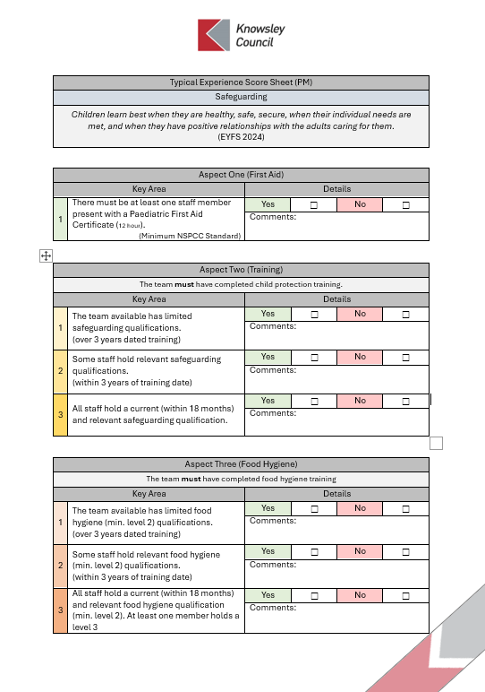
TESS
If you are finding yourself consistently highlighting 1s & 2s or have found that a change you have made has led to lower results; it may be time to consider changing aspects of the provision or even feeding these into supervisions to support CPD and access to Knowsley led courses e.g. Safeguarding Training
A simplified Yes | No format should allow for speed of completion.
The comments section is an opportunity to list evidence or a place to jot notes for ideas for future development.
Only tick Yes for one area 1|2|3 if this is evident in your practice/provision.
Don’t be afraid to grade low, be honest and use this as a starting point to push quality.
Don’t be afraid to grade high, if you have the evidence in practice this form can be used to support your Ofsted preparation.

Typical Experience Score Sheet (PM)
Inclusion
“It is important to recognise the different needs of the children who will be accessing wraparound care and ensure that new and existing provision is accessible to all, including children with complex needs and those in specialist school settings.”
(National Wraparound Childcare Programme Handbook 2024)

Experience One (Equality Act 2010 Awareness)
Key Area |  | Details
1 | The team are unaware of the Equality Act 2010 and its impact on provision and practice. | Yes | ☐ | No | ☐
1 |  | Comments:
2 | The team are confidence when explaining the Equality Act 2010 and the impact it has had on their provision and practice. | Yes | ☐ | No | ☐
2 |  | Comments:

Experience Two (Inclusion, Diversity & Belonging Training)
Key Area |  | Details
1 | The team available has limited inclusion, diversity & belonging qualifications.  (over 3 years dated training) | Yes | ☐ | No | ☐
1 |  | Comments:
2 | Some staff hold relevant inclusion, equality & belonging qualifications.  (within 2 years of training date) | Yes | ☐ | No | ☐
2 |  | Comments:
3 | All staff hold a current (within 18 months) and relevant inclusion, diversity & belonging training including the Equality Act 2010 training. | Yes | ☐ | No | ☐
3 |  | Comments:

Experience Three (Demographics Awareness)
Key Area |  | Details
1 | The team are unaware of the demographics of children and families in the local community and those that access their provision. | Yes | ☐ | No | ☐
1 |  | Comments:
2 | The team are aware of the demographics of the children and families accessing the provision but this is not reflected in the resources and spaces provided. | Yes | ☐ | No | ☐
2 |  | Comments:
3 | The team consciously reflect the community, families and children accessing their provision. They are confident when discussing their provisions place in the community and how they support children from all backgrounds. | Yes | ☐ | No | ☐
3 |  | Comments:

Experience Four (Protected Characteristics Awareness)
Key Area |  | Details
1 | The team are unsure of the protected characteristics and are not aware of their duties in preventing discrimination. | Yes | ☐ | No | ☐
1 |  | Comments:
2 | There is a conscious effort to learn about the protected characteristics. This is a culture of awareness and both conscious and unconscious bias is challenged regularly. | Yes | ☐ | No | ☐
2 |  | Comments:

Experience Five (Reasonable Adjustments)
Key Area |  | Details
1 | The provision is stationary with little to no adaptations made to accommodate the individual needs of children and staff. | Yes | ☐ | No | ☐
1 |  | Comments:
2 | The provision is adaptable, adjustments are made regularly to ensure equal access to all children and staff. | Yes | ☐ | No | ☐
2 |  | Comments:

Experience Six (Awareness of Equity & Equality)
Key Area |  | Details
1 | The team are unaware of the different between equity and equality which is reflected in their planning and adaptations | Yes | ☐ | No | ☐
1 |  | Comments:
2 | The team are confident when explaining the difference between equity and equality. Planning and adaptations represent a natural shift towards equity and allow for all children to flourish. | Yes | ☐ | No | ☐
2 |  | Comments:

Experience Seven (Equal Opportunities)
Key Area |  | Details
1 | The Equal Opportunities Statement and Policy is not reviewed regularly (or) does not reflect the demographics of the children, staff and families accessing the provision. | Yes | ☐ | No | ☐
1 |  | Comments:
2 | The Equal Opportunities Statement and Policy is reviewed and updated regularly to reflect the changing cohorts of children, families and staff accessing the provision. | Yes | ☐ | No | ☐
2 |  | Comments:

Experience Eight (Representation)
Key Area |  | Details
1 | The resources, pictures, displays and spaces do not reflect the protected characteristics of the children, staff and families accessing the provision. | Yes | ☐ | No | ☐
1 |  | Comments:
2 | Resources, pictures, displays and spaces reflect the protected characteristics of the children, staff and families accessing the provision. Children feel a sense of belonging and have aspirational role models/figures to aspire to in the imagery that surrounds them. | Yes | ☐ | No | ☐
2 |  | Comments:

Experience Nine (Celebration vs Tokenism)
Key Area |  | Details
1 | The team are unaware of the deeper cultural meanings of key events and milestones often reducing these to tokenistic displays or templates of perceived norms. | Yes | ☐ | No | ☐
1 |  | Comments:
2 | The team act respectfully and engage families when acting on opportunities to celebrate cultural events and milestones. Celebrations are authentic and well planned out representing the underlying principles of events as opposed to tokenistic representation or templates. | Yes | ☐ | No | ☐
2 |  | Comments:

Experience Ten (Gender Neutrality)
Key Area |  | Details
1 | The layout, resources, colours and imagery in certain areas and activities have the potential to perpetuate gender stereotypes and marginalise some children and staff. | Yes | ☐ | No | ☐
1 |  | Comments:
2 | The layout, resources, colours and imagery associated with spaces allows all children to engage equally regardless of gender. Activities and resources are planned to allow for all genders to access them and achieve equally. Spaces and resources are reviewed regularly to ensure they promote inclusivity. | Yes | ☐ | No | ☐
2 |  | Comments:

Experience Eleven (Behaviour Support)
Key Area |  | Details
1 | There are inconsistencies across the team when supporting behaviour. These interactions may cause behaviours to escalate or fail to address the cause of the conflict | Yes | ☐ | No | ☐
1 |  | Comments:
2 | There is a consistent and supportive approach to supporting positive behaviour across the team. This may occasionally be adapted to suit specific children but this adaptation is inclusive rather than isolating. | Yes | ☐ | No | ☐
2 |  | Comments:

Experience Twelve (English As An Additional Language)
Key Area |  | Details
1 | There is limited differentiation in place to support children, families and staff with EAL. The team are unaware of how to communicate with families and children while spaces, labelling and books limit the inclusion of children with EAL. | Yes | ☐ | No | ☐
1 |  | Comments:
2 | EAL is not a barrier to inclusion. The team make reasonable adjustments including translated documents for families, translated labelling for children and in some cases memorise key words and phrases to help communication with children and families. | Yes | ☐ | No | ☐
2 |  | Comments:

Experience Thirteen (Experiential Learning [Exes])
Key Area |  | Details
1 | The team are unaware of the EXE scale. The wellbeing and involvement of the children is not considered in decision making or planning. | Yes | ☐ | No | ☐
1 |  | Comments:
2 | Wellbeing and Involvement are considered and placed at the centre of the decision making and planning process (especially during transitions. | Yes | ☐ | No | ☐
2 |  | Comments:

Experience Fourteen (Mental Health)
Key Area |  | Details
1 | Staff are not always approachable and may trivialise the emotions of children, operating a ‘brush it off’ approach. | Yes | ☐ | No | ☐
1 |  | Comments:
2 | There are opportunities for children to openly discuss emotions. These are actively pursued and discussed with the team with staff presenting proactive solutions or consoling upset children. Staff pursue the triggers and causes of emotions enabling children to better understand the things affecting them. | Yes | ☐ | No | ☐
2 |  | Comments:

Experience Fifteen (Accessibility)
Key Area |  | Details
1 | The provisions accessibility is limited with little to no measures in place to accommodate children with physical or cognitive impairments. | Yes | ☐ | No | ☐
1 |  | Comments:
2 | The team are aware of the limits of their provision and activities and take reasonable measures to adjust the provision and activities to support inclusion. The provision is accessible to all children with adjustments made within the provision to adapt to the individual needs of children. | Yes | ☐ | No | ☐
2 |  | Comments:

Experience Sixteen (Sensory Diet Awareness)
Key Area |  | Details
1 | The team are unaware of the Sensory Diet needs of the children accessing the provision and how to differentiate for these | Yes | ☐ | No | ☐
1 |  | Comments:
2 | The team are able to confidently present each child’s individual sensory needs and how they are able to adapt the provision and differentiate for these children. | Yes | ☐ | No | ☐
2 |  | Comments:



