



Knowsley Wraparound

TESS Guide

Aspect 7
Safeguarding


“Safeguarding the rights of others is the most noble and beautiful end of a human being.”
- KHALIL GIBRAN


The Typical
Experience
Score Sheets (TESS)

A Guide To
Grading Scale – designed to promote reflection on key areas of the provision.
Consider the 1|2|3 format as a ladder for demonstrating progression (e.g. you may grade Term One a 1 and by the start of Term Three you may grade yourself a 3)
As your provision starts to feel established or evolves over time you may naturally feel that you have progressed through the ‘Areas’.
You may notice as children/team members settle some indicators will improve.
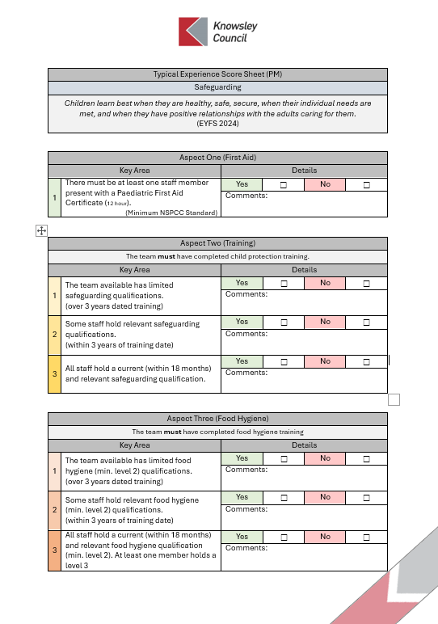
TESS
If you are finding yourself consistently highlighting 1s & 2s or have found that a change you have made has led to lower results; it may be time to consider changing aspects of the provision or even feeding these into supervisions to support CPD and access to Knowsley led courses e.g. Safeguarding Training
A simplified Yes | No format should allow for speed of completion.
The comments section is an opportunity to list evidence or a place to jot notes for ideas for future development.
Only tick Yes for one area 1|2|3 if this is evident in your practice/provision.
Don’t be afraid to grade low, be honest and use this as a starting point to push quality.
Don’t be afraid to grade high, if you have the evidence in practice this form can be used to support your Ofsted preparation.

Typical Experience Score Sheet
Safeguarding
Children learn best when they are healthy, safe, secure, when their individual needs are
met, and when they have positive relationships with the adults caring for them.
(EYFS 2024)

Experience One (First Aid)
Key Area |  | Details
1 | There must be at least one staff member present with a Paediatric First Aid Certificate (12 hour).  (Minimum NSPCC Standard) | Yes | ☐ | No | ☐
1 |  | Comments:

Experience Two (Training)
The team must have completed child protection training.
Key Area |  | Details
1 | The team available has limited safeguarding qualifications.  (over 3 years dated training) | Yes | ☐ | No | ☐
1 |  | Comments:
2 | Some staff hold relevant safeguarding qualifications.  (within 2 years of training date) | Yes | ☐ | No | ☐
2 |  | Comments:
3 | All staff hold a current (within 18 months) and relevant safeguarding qualification. | Yes | ☐ | No | ☐
3 |  | Comments:

Experience Three (Food Hygiene)
The team must have completed food hygiene training
Key Area |  | Details
1 | The team available has limited food hygiene (min. level 2) qualifications.  (over 3 years dated training) | Yes | ☐ | No | ☐
1 |  | Comments:
2 | Some staff hold relevant food hygiene  (min. level 2) qualifications.  (within 3 years of training date) | Yes | ☐ | No | ☐
2 |  | Comments:
3 | All staff hold a current (within 18 months) and relevant food hygiene qualification (min. level 2). At least one member holds a level 3. Staff are vigilant and careful not to cross contaminate allergies/intolerances. | Yes | ☐ | No | ☐
3 |  | Comments:
Experience Four (Ratios [Older Than Reception Age])
A team member must hold a Level 2 in a subject related to the service provided
Key Area |  | Details
1 | There is one member of staff to 30 children. Toilet facilities are within hearing distance of lone worker. Whilst eating, children must be within sight and hearing.  (Must have a Lone Worker Policy) | Yes | ☐ | No | ☐
1 |  | Comments:
2 | There is one member of staff to every ten children. There are a minimum of two staff present at all times. Toilet facilities are within hearing. Whilst eating, children must be within sight and hearing. | Yes | ☐ | No | ☐
2 |  | Comments:

Experience Five (Ratios [Younger Than Reception Age])
A team member must have a full & relevant Level 3 Qualification
Key Area |  | Details
1 | There is one member of staff to 8 children. Toilet facilities are within hearing distance of lone worker. (Must have a Lone Worker Policy) | Yes | ☐ | No | ☐
1 |  | Comments:
2 | There is one member of staff to 8 children. There are a minimum of 2 staff present at all times. | Yes | ☐ | No | ☐
2 |  | Comments:

Experience Six (Medication)
Key Area |  | Details
1 | The team has limited knowledge of medication/allergy details of children in their care. (only one trained/aware professional) | Yes | ☐ | No | ☐
1 |  | Comments:
2 | Some members of the team are aware of medication/allergy details of the children in their care and the policy for administering medicines. | Yes | ☐ | No | ☐
2 |  | Comments:
3 | The whole team are regularly updated on the medication/allergy details of all children in their care. Regular/recent training reinforces this professionalism. (Within 3 years) | Yes | ☐ | No | ☐
3 |  | Comments:

Experience Seven (Policies)
Key Area |  | Details
1 | The team are unaware of safeguarding policies and how they influence their practice/procedures/premises | Yes | ☐ | No | ☐
1 |  | Comments:
2 | The team are aware of policies pertaining to their practice/procedures/premises, but these are not regularly reviewed or updated | Yes | ☐ | No | ☐
2 |  | Comments:
3 | The team are actively involved in the development and implementation of policies effecting their practice. They are confident when talking about policies. | Yes | ☐ | No | ☐
3 |  | Comments:

Experience Eight (Premises)
Key Area |  | Details
1 | There is the potential for pedestrians to gain access to the premises. The premises are not secure with boundaries / access points either damaged or faulty | Yes | ☐ | No | ☐
1 |  | Comments:
2 | Schools have effective procedures for controlling access and barring individuals from school premises. The premises are secure with all access points visible and intercom systems limiting access. | Yes | ☐ | No | ☐
2 |  | Comments:

Experience Nine (Intimate Care & Toileting)
Key Area |  | Details
1 | Privacy is limited, the space is cluttered with potential access to cleaning products. Staff are not trained specifically in intimate care routines. | Yes | ☐ | No | ☐
1 |  | Comments:
2 | Toilets/changing areas are in secure locations with no visibility to other children/adults. Staff are trained specifically in Intimate Care and policies are readily available. | Yes | ☐ | No | ☐
2 |  | Comments:

Experience Ten (Sleeping)
Sudden infant death syndrome (SIDS) - NHS (www.nhs.uk)
The Lullaby Trust - Safer sleep for babies, Support for families
Key Area |  | Details
1 | Sleeping children must be frequently checked to ensure that they are safe.  Being safe includes ensuring that cots and bedding are in good condition and suited to the age of the child,  EYFS 2024 | Yes | ☐ | No | ☐
1 |  | Comments:

Experience Eleven (Flow Charts)
Key Area |  | Details
1 | There are no visible KSCP Flowcharts in the space being used for wraparound. | Yes | ☐ | No | ☐
1 |  | Comments:
2 | The KSCP Flowcharts available are outdated containing improper contact details and links. | Yes | ☐ | No | ☐
2 |  | Comments:
3 | Flow Charts are accessible and up to date. These are reviewed and updated in line with LA guidance/emails. Practitioners are confident with how to use these and how to follow the information / processes.  For cross borough children, there are corresponding flowcharts available. | Yes | ☐ | No | ☐
3 |  | Comments: in section state need to identify key people/roles i.e. LADO

Experience Twelve (Encompass)
Key Area |  | Details
1 | The team receiving phone calls are not fully trained in Operation Encompass processes. | Yes | ☐ | No | ☐
1 |  | Comments:
2 | There is a member of the team who is fully trained in Operation Encompass processes available at all times. The rest of the team knows who this is and works with them to support children in question. | Yes | ☐ | No | ☐
2 |  | Comments:

Experience Thirteen (Locating)
Key Area |  | Details
1 | There are moments when children are not visible or team members are unaware child locations. This can lead to confusion or potential safety concerns. | Yes | ☐ | No | ☐
1 |  | Comments:
2 | The team are aware of children’s locations at all times. The provision is well mapped and there is good visibility. Any breaks in contact e.g. toileting are timed and discussed with colleagues. | Yes | ☐ | No | ☐
2 |  | Comments:

Experience Fourteen (Disclosure)
Key Area |  | Details
1 | The team rarely make themselves available for children to discuss concerns. The environment is loud and busy, not necessary allowing for conversations to take place. | Yes | ☐ | No | ☐
1 |  | Comments:
2 | There are opportunities for children and staff to make disclosures safely. The environmental volume and activities on offer e.g. Monkey Bob promote a culture of disclosure. | Yes | ☐ | No | ☐
2 |  | Comments:

Experience Fifteen (Parent Partnership)
Key Area |  | Details
1 | Parents are unaware of the safeguarding responsibilities of the team including challenging collectors and emergency contacts, this occasionally leads to conflict. | Yes | ☐ | No | ☐
1 |  | Comments:
2 | Parents play an active part in safeguarding; they are regularly consulted with and actively contribute to policies/procedures. They are made aware of processes including challenging collectors and emergency contacts. | Yes | ☐ | No | ☐
2 |  | Comments:



