



Knowsley Wraparound

Next Steps &

Useful Links

Aspect 7
Safeguarding


“Safeguarding the rights of others is the most noble and beautiful end of a human being.”
- KHALIL GIBRAN

Guidance
& Useful Links
Next Steps
Aspect One – First Aid
Why is this important?
As an educator you are tasked primarily with the protection and care of children accessing your provision. The Paediatric First Aid (PFA) qualification and the skill set this gives you not only helps you to manage any accidents and incidents that may happen under your supervision but increase your awareness of the potential risks facing children in your care. The PFA will also give you and your team the confidence to manage often overlooked aspects of care including breakfast/dinner times and how you can intervene in potential choking or scolding incidents should they arise.

The Guidance:
At least one person who has a current paediatric first aid (PFA) certificate must be on the premises and available at all times when children are present and must accompany children on outings.
EYFS Statutory Framework (2024)

Additional Guidance:
Provision should be enough to ensure that first aid can be administered without delay should the occasion arise, and be available at all times. This means that arrangements should take account of absences of a first aider or appointed person and reflect alternative work practices.
First aid in schools, early years and further education, DfE (2022)

Considerations For Next Steps
Set a safeguarding lead for the wraparound provision, even if this is different from your overall lead.
Regularly review and amend you first aid policy; you could as for this process to be added to your supervisions.
Update your training regularly, a minimum of once every 3 years.
Place posters around the provision so those accessing or those covering absences can quickly identify named leads and qualification levels.
Place posters around the provision that include PFA advice on how to manage potential incidents e.g. a choking poster near eating areas.
Audit yourself regularly or have contact with those that do to ensure first aid kits and burns kits are in date and suitable for the children accessing the Wraparound Childcare.

Aspect Two – Training
Why is this important?
It is of paramount importance that those tasked with safeguarding children and young people have the knowledge and skills needed to take decisive action if needed. While safeguarding roles may vary across the team regular training helps all those working with children to understand the role they play in keeping children safe; this includes the ability to recognise signs and indicators previously mentioned in this toolkit. Regular training also gives you confidence and the knowledge gained with help you stay calm during challenging moments and conversations.

The Guidance:
Governing bodies and proprietors should ensure that all staff undergo safeguarding and child protection training at induction. The training should be regularly updated. Induction and training should be in line with any advice from local safeguarding partners
Keeping Children Safe In Education (2024)

Additional Guidance:
Providers must train all staff to understand their safeguarding policy and procedures and ensure that all staff have up to date knowledge of safeguarding issues. Training made available by the provider must enable staff to identify signs of possible abuse and neglect at the earliest opportunity, and to respond in a timely and appropriate way.
EYFS Statutory Framework (2024)

Considerations For Next Steps
Speak to the safeguarding lead for the wraparound provision about accessing Local Authority safeguarding training.
Regularly review and amend you CPD policy; you could ask for this process to be added to your supervisions.
Update your training regularly, a minimum of once every 2 years.
Access learning.NSPCC.org.uk for further training on specific aspects of safeguarding.
Speak to your Operation Encompass Lead to better understand the role you play in this process; you may need to speak to your safeguarding lead to access this training if it is applicable to your role.

Aspect Three – Food Hygiene
Why is this important?
While most aspects of food preparation and storage will more than likely be under the supervision of catering/kitchen staff you still hold a pivotal role in handling and delivering food. Safe practices not only ensure that both you and the children are safe from the dangers associated with food preparation e.g. scalding but also gives you the foundation for protecting children from food poisoning and allergic reactions. All staff who handle food must take care to avoid cross contamination and accidental transfer of allergens to vulnerable children, Food Hygiene training helps to build this awareness.

The Guidance:
Providers must be confident that those responsible for preparing and handling food are competent to do so. All staff involved in preparing and handling food must receive training in food hygiene.
EYFS Statutory Framework (2024)

Additional Guidance:
All schools (and any catering contractors used) must comply with food safety laws and adopt good hygiene practices. If they do not, it increases the risk of contamination and can make food unsafe. Contaminated food can make pupils and staff ill, cause injuries and may even be life-threatening in some cases
cpdonline.co.uk (2024)

Considerations For Next Steps
Enquire about the availability for all team members to be trained in Food Hygiene (Level 2) with one potentially training in Food Hygiene (Level 3)
Regularly review and amend you first aid policy; you could ask for this process to be added to your supervisions.
Update your training regularly, a minimum of once every 3 years.
Place posters around the provision so those accessing or those covering absences can quickly identify allergies and intolerances.
Consider health care plans including next steps, emergency contacts and EpiPen locations.
Audit yourself regularly or have contact with those that do to ensure first aid kits and burns kits are in date and suitable for the children accessing the Wraparound Childcare.

Aspect Four – Ratios (Children Older Than Reception Age)
Why is this important?
Under The School Admissions (Infant Class Sizes) (England) Regulations 2012 the maximum infant class size (s4) is set at 30. Under the EYFS (2024) it is a statutory duty that where the provision is solely before/after school care, the setting must have sufficient staff to enable it to care for groups of no more than 30 children. This is an important consideration to make because under the heading of safeguarding, you must consider the limitations of the ratio you are working under and the impacts this may have on your ability to safeguard the children accessing your provision.

The Guidance:
Where provision is solely before/after school care or holiday provision for children who normally attend reception class (or older) during the school day, there must be sufficient staff as for a class of 30 children
National Wraparound Childcare Programme Handbook (2024)

Additional Guidance:
It is for providers to determine how many staff are needed to ensure the safety and welfare of children, bearing in mind the type(s) of 45 activity and the age and needs of the children. It is also for providers to determine what qualifications, if any, the manager and/or staff should have.
National Wraparound Childcare Programme Handbook (2024)

Considerations For Next Steps
As the above is statutory guidance ratios must be adhered to at all times, unless, under exceptional circumstances the safety and security of children can be maintained i.e. during an emergency/injury.
Have a copy of your Lone Worker policy to hand should a situation ever arise where this may be needed.
Have a breakdown of the children accessing the provision and their ages to better gauge the mixture of ratios necessary.
Challenge, if needed, current staff:child ratios if you feel unable to maintain high safeguarding standards in the provision due to the limits on staffing.

Aspect Five – Ratios (Children Younger Than Reception Age)
Why is this important?
To ensure the safety of all children accessing their provision. under the EYFS (2024) children aged 2 must have at least 1 member of staff to every 5 children. For child aged 3+ it is statutory to have 1 member of staff to every 8 children (extended to 13 if the teacher holds a relevant qualification). Children must usually be within sight and hearing of staff and always within sight or hearing. Whilst eating, children must be within sight and hearing of a member of staff. These ratios are designed to ensure that there are no limiting factors effecting staff members ability to meet the safeguarding and learning needs of the children accessing their provision.

The Guidance:
In settings on the early years register, the manager of the setting must hold an approved qualification of level 3 or above and at least half of all other staff must hold at least an approved level 2 qualification.
EYFS Statutory Framework (2024)

Additional Guidance:
For children aged three and over in independent schools where there is no person with Qualified Teacher Status, Early Years Professional Status, Early Years Teacher Status no instructor, and no suitably qualified overseas trained teacher, working directly with children:
• There must be at least one member of staff for every eight children.
EYFS Statutory Framework (2024)

First aid in schools, early years and further education, DfE (2022)

Additional Guidance:
Where schools have provision run by the governing body (under section 27 of the Education Act 2002) for three- and four-year-olds who are not pupils of the school, they can apply: a 1:13 ratio where a person with a suitable level 6 qualification is working directly with the children (as in paragraph 3.42); or a 1:8 ratio where a person with a suitable level 6 qualification is not working directly with children but at least one member of staff present holds a level 3 qualification.
EYFS Statutory Framework (2024)
EYFS Statutory Framework (2024)

Considerations For Next Steps
As the above is statutory guidance ratios must be adhered to at all times, unless, under exceptional circumstances the safety and security of children can be maintained i.e. during an emergency/injury.
Aspect Six – Medication
Why is this important?
The administration, storage and recording of medication is paramount in safeguarding children from potential overdosages and fabricated illnesses. It is also an important aspect of reducing the risk of seizures and febrile convulsions, something younger children or those with heat regulatory conditions may be more prone to. In more specialist cases it forms a crucial aspect of inclusion, enabling those with long tern health conditions to access education and out of school provisions that may have been historically closed to them.

The Guidance:
Providers must have and implement a policy, and procedures, for administering medicines to children. It must include systems for obtaining information about a child’s needs for medicines, and for keeping this information up to date.
EYFS Statutory Framework (2024)

Additional Guidance:
Medicines and devices such as asthma inhalers, blood glucose testing meters and adrenaline pens should be always readily available to children and not locked away. This is particularly important to consider when outside of school premises, e.g. on school trips.
Supporting Children At School With Medical Conditions (2015)

Considerations For Next Steps
Locate your medication storage points, particularly those pertaining to children registered with your wraparound provision.
Organise and safely store copies or know where to find copies of parental consent forms as these are compulsory to administering medication unless during exceptional circumstances whereby you would consult further legislation.
Have access to children’s individual care plans or familiarise yourself with those for children registered with your provision in case of an emergency.
Have a named team member (who must be Paediatric Frist Aid trained) who administers medication with a secondary ‘verifying’ team member to sign off administration forms.
Have a log of recorded medication administration forms, signed dated and easily accessible.
If you have children with long term or unique medical conditions accessing your wraparound provision, discuss accessing training by NHS specialists e.g. MIC-KEY G-Tubes training on how best to support that child.
Aspect Seven – Policies
Why is this important?
Robust safeguarding and child protection policies form the bedrock of all educational settings. Active participation in and contribution towards these policies not only increase your competencies but also give you a sense of ownership over your provision. With the breadth of policies in place in education settings it is important to know where to access those that effect your provision directly and familiarise yourself with these, not only to keep your children safe but to also support your conduct in the case of a parental/external challenge.

The Guidance:
All staff should be aware of systems within their school or college which support safeguarding, and these should be explained to them as part of staff induction.
Keeping Children Safe In Education (2024)

Additional Guidance:
If staff have a concern, they should follow their own organisation’s child protection policy and speak to the designated safeguarding lead (or a deputy).
Keeping Children Safe In Education (2024)

Considerations For Next Steps
Familiarise yourself with the location of your key policies. Having access to these can not only help reassure you but also parents of children in your care.
Don’t be afraid to share policies or aspects of them with parents, this can help them to understand how you work and how they can support you.
Have key aspects of your policies or procedures on posters around the room. These can be an easy point of reference if needed.
Try to have regular discussions and actively participate in team meetings where discussions around policies are being held. These can help you understand the reasoning behind these policies and also give you the opportunity to add elements that suit the needs of your wraparound provision.

Aspect Eight – Premises
Why is this important?
A secure premises lays the foundation for any provision. Knowing who is on the premises and where they are not only gives you peace of mind but also enables you to safeguard the children in your care. Secure access points with intercom systems, covered by cameras will limit access and reduce the opportunity for serious incidents, including Lock Down Incidents. Having clear boundaries and secure access points also allows for children to freely interact with the provision without fear of escape or access to things they shouldn’t.

The Guidance:
Many regulations state that provision must be ‘suitable’. This is not precisely defined, but schools must take into account the age, number and sex of pupils, and any special requirements they have, when determining whether provision is suitable.
Advice On Standards For School Premises (2015)

Additional Guidance:
Schools are private property. People do not have an automatic right to enter. Parents have an ‘implied licence’ to come on to school premises at certain times…Schools should set out their rules for this and tell parents what they are.

Controlling Access To School Premises (2018)

Considerations For Next Steps
Familiarise yourself with any intercom/camera systems in place to support you.
Tour your provision and check if access points are clearly labelled.
Consider mapping your provision and putting a map up as a poster for ease of use.
Conduct regular (termly if possible) risk assessments through the lens of safeguarding, thinking about access points and lock down locations. Also, conducting this through the lens of a child may or including children in this process may illuminate escape points or risks you may have overlooked.
Feel free to regularly discuss enhancements to safety measures with your team, supervisors or managers; however, keep in mind the limitations of the space and finances involved.

Aspect Nine – Intimate Care / Toileting
Why is this important?
An often overlooked aspect of the provision, safe and suitable toileting facilities are important as these may, in the cases of older children, be one of the only situations in which children aren’t supervised. For younger children, safeguarding their privacy and protecting them from harm form the cornerstones on any high quality intimate care process. Training on this specifically can give you and your team the confidence to change children safely whilst enhancing this process towards becoming an amazing attachment moment between key person and child.

The Guidance:
Toilet facilities need to be planned and designed so that... they are located in areas around the school that provide easy access for pupils and allow for informal supervision by staff, without compromising pupils’ privacy.
Advice On Standards For School Premises (2015)

Additional Guidance:
Providers must ensure:
- There is an adequate number of toilets and hand basins available – there should usually be separate toilet facilities for adults.
- There are suitable hygienic changing facilities for changing any children who are in nappies.
EYFS Statutory Framework (2024)

Considerations For Next Steps
Update you training regularly, preferably once every 3 years.
Familiarise yourself with your organisations intimate care/toileting supervision policies and procedures to not only safeguard yourself but also ensure you are conducting yourself in line with the organisation.
Consider mapping your locations for covering staff and also consider timing average toilet use times to gauge an idea of when intervention may be needed.
Conduct regular (termly if possible) risk assessments of facilities to ensure cleaning products, access etc is secure.
Review sight lines for intimate care/changing facilities to ensure privacy.
Discuss with supervisors/manager regularly any concerns or limitations to intimate care moments/toileting due to facilities or staffing.
Aspect Ten – Sleeping
Why is this important?
Research suggests that children between 3 and 5 years of age are likely to sleep longer and take irregular naps during the day. One of these naps might happen during your wraparound provision and being prepared for this is important. The Lullaby Trust and Great Ormond Street Hospital provide a wide array of tips and guidance on how to safely monitor children’s sleep and how to provide safe and suitable sleeping arrangements for all ages. Remember, some children’s sleep is unsettled and interrupted so your cosy spaces may be the only safe sleeping space they experience.
The Guidance:

Sleeping children must be frequently checked to ensure that they are safe. Being safe includes ensuring that cots and bedding are in good condition and suited to the age of the child, and that babies are placed down to sleep safely in line with the latest government safety guidance: Sudden infant death syndrome (SIDS) - NHS (www.nhs.uk).
EYFS Statutory Framework (2024)

Additional Guidance:
Your child’s sleeping environment should be a place where they feel safe and secure, but also be a place to sleep and not play. There are ways in which the sleeping environment can be adjusted, which will depend on the needs of your child (and other children sharing the room).
Great Ormond Street Hospital, Sleep Hygiene In Children & Young People (2023)

Considerations For Next Steps
Regardless of age, monitor the position and location of sleeping children to ensure safety and reduce the risk of suffocation.
Place posters around cosy spaces or spaces where children regularly frest with safer sleep guidance for the team to refer to if needed.
If needed it may be helpful to have designated cosy/rest spaces in the provision as wraparound provision will usually be an extension of the typical school day meaning children are more likely to be tired.
Update you training regularly, preferably once every 3 years or in line with PFA. Depending on the age of children accessing the provision consider more age focused, specialised training.

Aspect Eleven – Flow Charts
Why is this important?
For younger children, local authority safeguarding flowcharts must be regularly available and displayed prominently in the provision. These flowcharts work in conjunction with safeguarding training to ensure staff know the correct avenues to take in order to address safeguarding concerns in the provision. These flowcharts also contain useful information which team members must be aware of when discussing safeguarding competencies with external professionals e.g. LADO (Local Authority Designated Officer).

The Guidance:
Contact the Multi-Agency Safeguarding Hub (MASH) Team on 0151 443 2600 and speak to someone from Social Care. A Social Worker works for the government, and their job is to help you if you need to be protected from harm.
Knowsley.gov.uk, Safeguarding Children (2024)

Additional Guidance:
Schools and colleges should have their own procedures for dealing with safeguarding concerns or allegations against those working in or on behalf of schools and colleges in a paid or unpaid capacity, i.e. members of staff, including supply teachers, volunteers and contractors.
Keeping Children Safe In Education (2024)

Considerations For Next Steps
Displaying flowcharts prominently so that all staff know where to refer to, especially in intimate care/toileting areas and staff rooms. Familiarise yourself and your team with these locations.
Study the names and roles on the flowchart, it is important to know how this affects you and your children. It is also useful to know how to follow the process properly as accidental escalation in the wrong order may create concerns.
Support a culture of anonymity and whistleblowing; this will not only ensure higher safeguarding outcomes but promote an ethos appropriate challenge.
Consider whether you have posters available for children to access as they may not feel comfortable reporting it in school but may see self reporting to an organisation like MASH or the NSPCC as safer.
If lost or damaged, speak to your safeguarding lead about contacting the relevant agency or local authority in order to download and display these flowcharts.

Aspect Twelve – Encompass
Why is this important?
This is especially relevant to those wraparound providers offering breakfast/morning clubs. A charitable organisation, Operation Encompass works in conjunction with police to ensure that educational setting’s Designated Safeguarding Leads / Officers (Key Adults) are contacted in the event of child witnessing a case of Domestic Violence. While this information may not be passed on explicitly, you may be given a briefing to make reasonable adjustments to your provision, practice or behaviour support procedures for specific children in your care as a result of an Operation Encompass call.

The Guidance:
Operation Encompass is a police and education early information safeguarding partnership enabling schools to offer immediate support to children experiencing domestic abuse.
Operationencompass.org (2024)

Additional Guidance:
Children are negatively impacted by experiencing domestic abuse and without early intervention and support this negative impact can last through a child’s life course. Domestic abuse can impact upon social, psychological, physical, emotional and behavioural outcomes with an often negative impact upon a child’s academic success. Experiencing domestic abuse has been identified as an Adverse Childhood Experience.
Operationencompass.org (2024)

Considerations For Next Steps
Always have a registered Safeguarding Officer available during breakfast/morning club to receive these phone calls and make suggested adjustments/accommodations for the children effected.
Operation Encompass has free ‘Key Adult’ training available so if limits to staffing or staff turnover leads to a lack of a named ‘Key Adult’, discuss accessing this with your supervision/manager.
In any cases were information or adjustments have been disclosed, maintain confidentiality at all times to safeguarding both the children and yourself from escalated threats of harm.

Useful Links

First Aid | EYFS statutory framework for group and school-based providers  First aid in schools, early years and further education - GOV.UK  Home - Albany Training
Paediatric First Aid training course | St John Ambulance
Paediatric first aid course (2-day) | Red Cross Training
Legal Requirements for First Aid in Schools - STS First Aid

Example First Aid Poster:

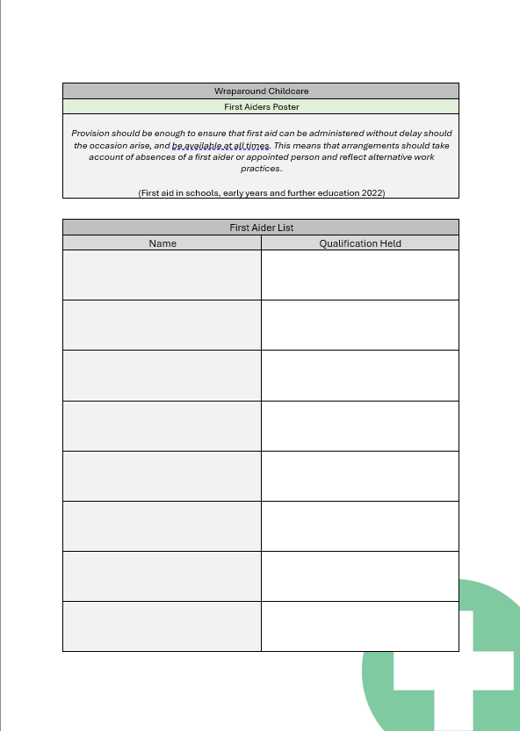

Training | EYFS statutory framework for group and school-based providers  Keeping children safe in education 2024  Apprenticeships, Skills, Children and Learning Act 2009
Safeguarding and child protection training in schools | NSPCC Learning
Schools Safeguarding | ASK Knowsley
Teachers’ Standards guidance
Teaching online safety in schools - GOV.UK
Promoting children and young people’s mental health and wellbeing
The Further Education Teachers’ Continuing Professional Development and Registration (England) Regulations 2007
Knowsley Safeguarding Children Partnership
You can also enquire with Knowsley Early Years Quality Assurance Team for bespoke Safeguarding & Designated Safeguarding Officer training.

Example Training Matrix:
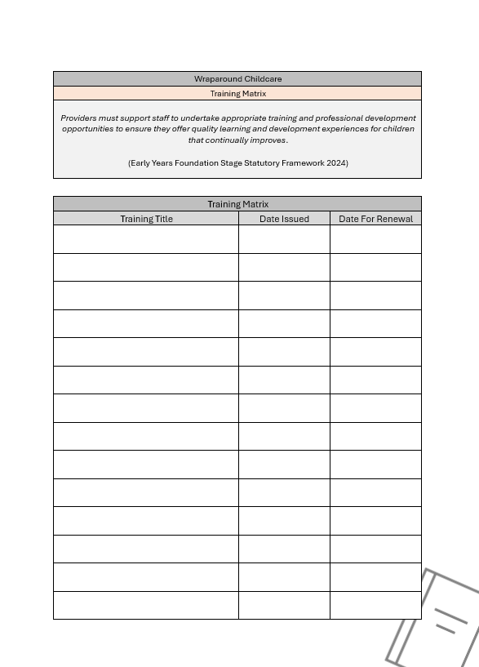

Food Hygiene | EYFS statutory framework for group and school-based providers  Homepage | Food Standards Agency  Allergies at School | Allergy UK | National Charity
Standards for school food in England - GOV.UK
The Requirements for School Food Regulations 2014
School meals - food standards - GOV.UK
Food safety - your responsibilities: Food hygiene - GOV.UK
Allergy guidance for schools - GOV.UK
Allergy information for schools | Anaphylaxis UK

Example Allergy Awareness Poster:
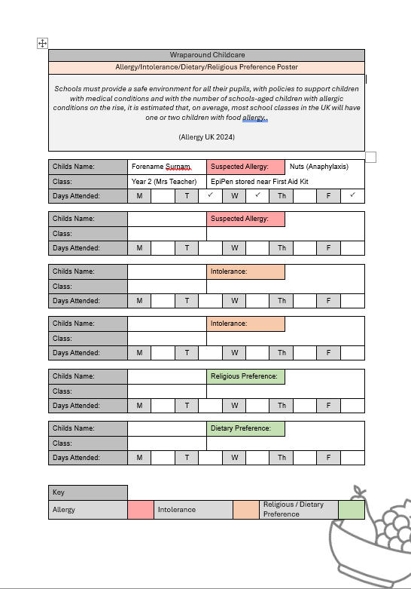

Ratios | EYFS statutory framework for group and school-based providers  Keeping children safe in education 2024  National Wraparound Childcare Programme Handbook
NASUWT | Class Sizes
School workforce in England, Reporting year 2023 - GOV.UK
How staff-to-child ratios work – Ofsted: early years
New regulations change childcare ratios in England
Lone working - HSE
Ofsted Guidelines for Lone Working in Schools - Ok Alone
Lone working policies: examples | The Key Leaders
Safeguarding children for lone workers | NSPCC Learning
Nursery policies and procedures - NDNA

Medication | EYFS statutory framework for group and school-based providers  First aid in schools, early years and further education - GOV.UK  Keeping children safe in education 2024
NASUWT | Administration of Medication
Administering medicines in school: guidance | The Key Leaders
Statutory guidance_on_supporting_pupils_at_school_with_medical_conditions.pdf

Example Medication Poster:

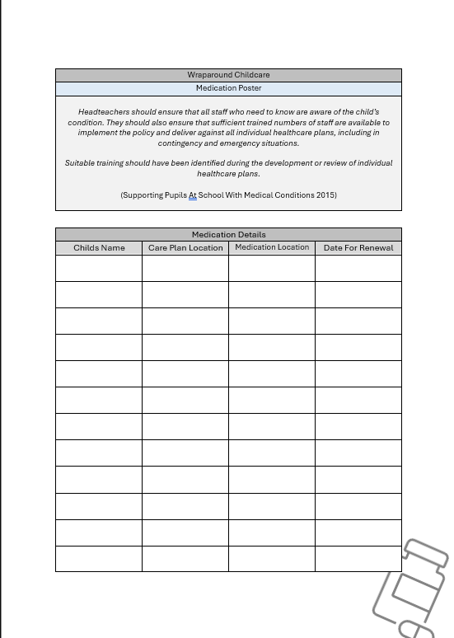

Policies | EYFS statutory framework for group and school-based providers  Department for Education Statutory Policies  Schools: statutory guidance - GOV.UK
Knowsley Safeguarding Children Partnership
Policy Writing Guidance - Policy Manual
Writing an influence and participation policy | Mind - Mind
After-school clubs, community activities, and tuition - safeguarding guidance for providers
Why we need to engage real people in policy development

Premises | EYFS statutory framework for group and school-based providers  Keeping children safe in education 2024  Childcare on domestic premises - GOV.UK
The School Premises (England) Regulations 2012
DfE Advice on Standards For School Premises
After-school clubs, community activities, and tuition - safeguarding guidance for providers
Controlling access to school premises - GOV.UK

Example Risk Assessment:

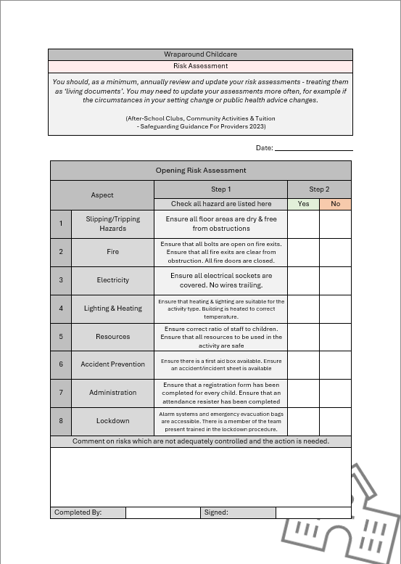

Intimate  Care / Toileting | EYFS statutory framework for group and school-based providers  Keeping children safe in education 2024  DfE Advice on Standards For School Premises
Establishing school-based nursery provision - GOV.UK
ERIC_Right To Go School Toilet Charter.pdf
Intimate care of children | NSPCC Learning

Example Intimate Care Log:

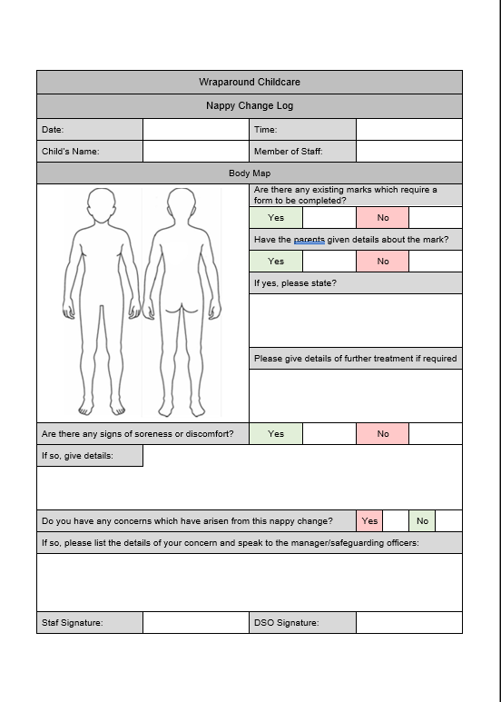

Sleeping | EYFS statutory framework for group and school-based providers  First aid in schools, early years and further education - GOV.UK  Keeping children safe in education 2024
Knowsley Safeguarding Children Partnership
Sleep hygiene in children and young people | Great Ormond Street Hospitale
Reduce the risk of sudden infant death syndrome (SIDS) - NHS
How to reduce the risk of SIDS for your baby - The Lullaby Trust

Example First Aid Poster:
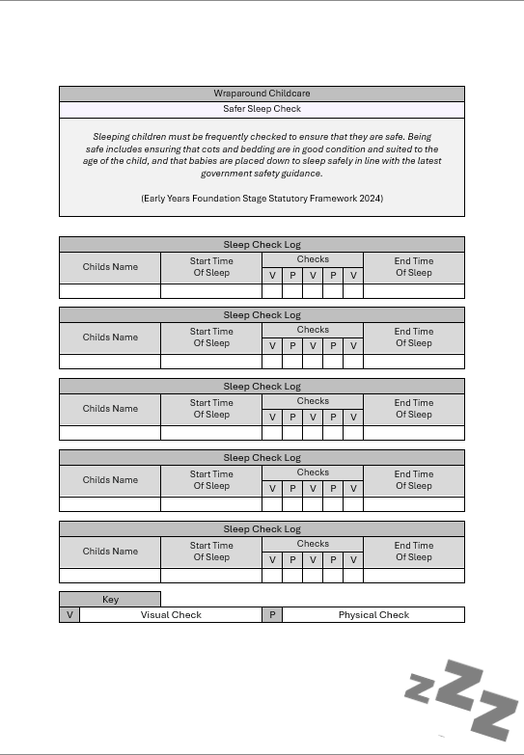

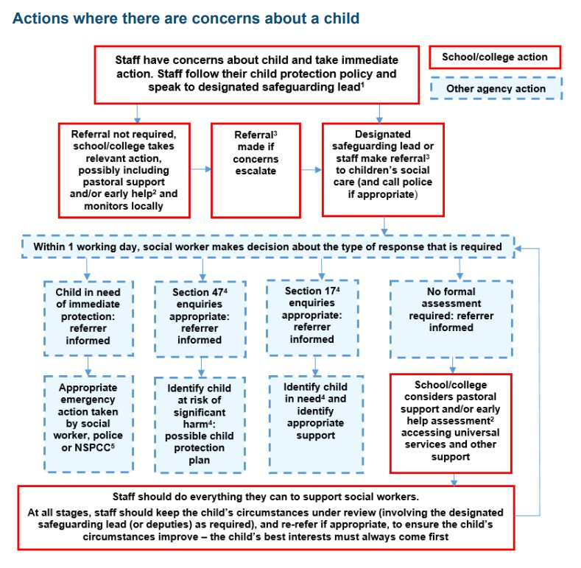
Flow Charts | EYFS statutory framework for group and school-based providers  Keeping children safe in education 2024  Knowsley Safeguarding Children Partnership
Useful Safeguarding Flow Charts:

Keeping Children Safe In Education, page 24, 2024

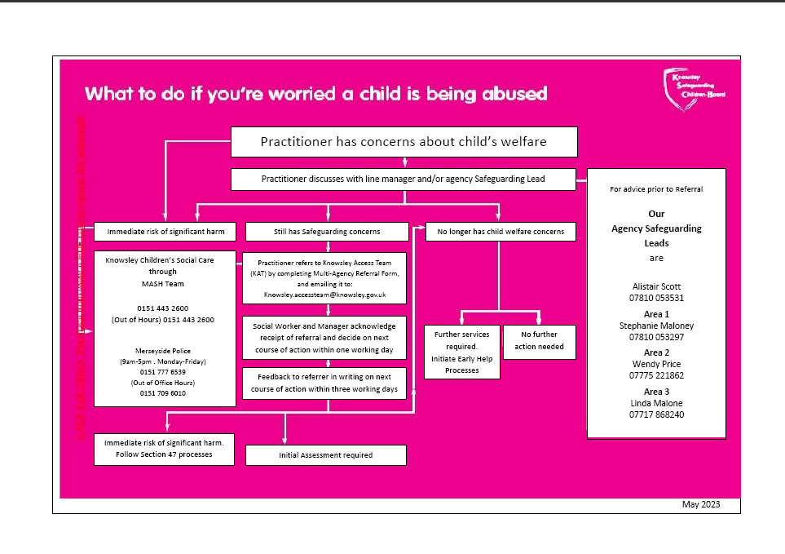

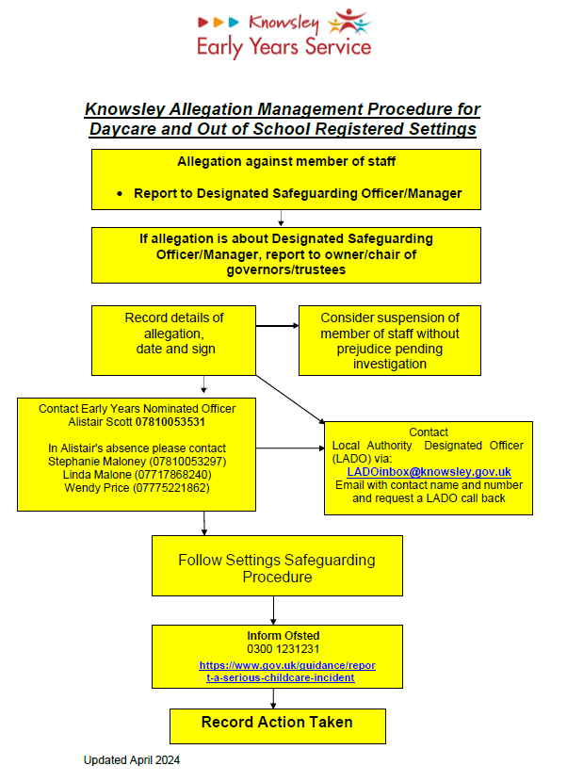

Encompass | Home : Operation Encompass  Operation Encompass Overview.pdf  Knowsley Safeguarding Children Partnership
Operation Encompass | Knowsley Council
Operation Encompass | Merseyside Police

Example Operation Encompass Poster & Call Log:

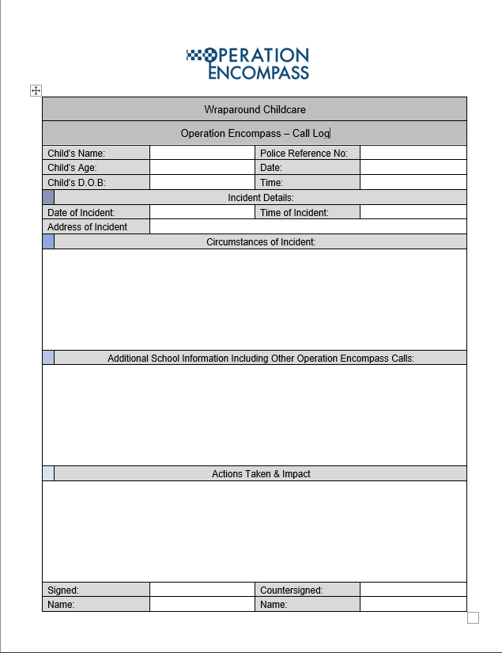

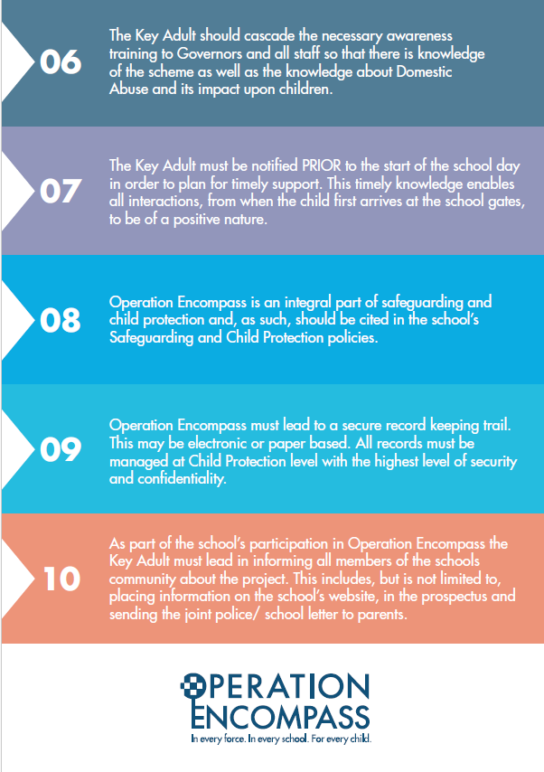
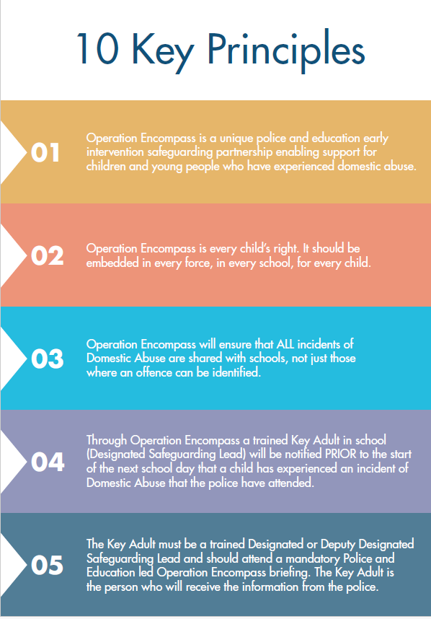

Locating | EYFS statutory framework for group and school-based providers  Keeping children safe in education 2024  Report a serious childcare incident - GOV.UK
Recommended adult to child ratios for working with children | NSPCC Learning
After-school clubs, community activities, and tuition - safeguarding guidance for providers
DfE Advice on Standards For School Premises

Disclosure | EYFS statutory framework for group and school-based providers  Keeping children safe in education 2024  Report a serious childcare incident - GOV.UK
Working together to safeguard children 2023: statutory guidance
Advice: Acoustic Design Of Schools

Parent  Partnership | EYFS statutory framework for group and school-based providers  First aid in schools, early years and further education - GOV.UK  Working together to safeguard children 2023: statutory guidance
Paediatric First Aid training course | St John Ambulance
Paediatric first aid course (2-day) | Red Cross Training
Legal Requirements for First Aid in Schools - STS First Aid



