



Knowsley Wraparound

TESS Guide


Aspect 1
Premises & Facilities

“When a flower doesn’t bloom, you fix the environment in which it grows, not the flower.”
- ALEXANDER DEN HEIJER


The Typical
Experience
Score Sheets (TESS)

A Guide To
Grading Scale – designed to promote reflection on key areas of the provision.
Consider the 1|2|3 format as a ladder for demonstrating progression (e.g. you may grade Term One a 1 and by the start of Term Three you may grade yourself a 3)
As your provision starts to feel established or evolves over time you may naturally feel that you have progressed through the ‘Areas’.
You may notice as children/team members settle some indicators will improve.
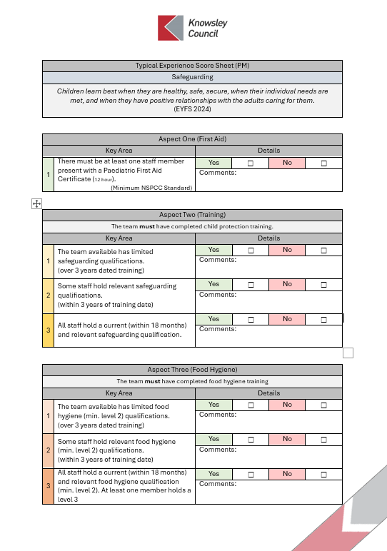
TESS
If you are finding yourself consistently highlighting 1s & 2s or have found that a change you have made has led to lower results; it may be time to consider changing aspects of the provision or even feeding these into supervisions to support CPD and access to Knowsley led courses e.g. Safeguarding Training
A simplified Yes | No format should allow for speed of completion.
The comments section is an opportunity to list evidence or a place to jot notes for ideas for future development.
Only tick Yes for one area 1|2|3 if this is evident in your practice/provision.
Don’t be afraid to grade low, be honest and use this as a starting point to push quality.
Don’t be afraid to grade high, if you have the evidence in practice this form can be used to support your Ofsted preparation.

Typical Experience Score Sheet
Premises & Facilities
Providers must ensure that their premises, including overall floor space and outdoor spaces, are fit for purpose and suitable for the age of children cared for and the activities provided on the premises.
(EYFS 2024)

Experience One (Secure Premises)
Key Area |  | Details
1 | There are breaks in the perimeter of the provision potentially allowing for unauthorised entry or exit from the provision | Yes | ☐ | No | ☐
1 |  | Comments:
2 | The premises are secure with boundaries inaccessible and untampered. A clear perimeter keeps both the team and children safe. | Yes | ☐ | No | ☐
2 |  | Comments:

Experience Two (Access Points)
Key Area |  | Details
1 | Access points cause distraction to the team, often requiring excess supervision and distracting from the children. Access points are faulty or insecure allowing for unauthorised/unsupervised exit and entry. | Yes | ☐ | No | ☐
1 |  | Comments:
2 | Intercom or camera systems allow for seamless supervision of access points. Points are visible and do not detract from the children. Collection and drop of processes are seamless with clear communication between the team. | Yes | ☐ | No | ☐
2 |  | Comments:

Experience Three (Accessibility)
Key Area |  | Details
1 | Reasonable adjustments are not made to accommodate the needs of children or families accessing the provision | Yes | ☐ | No | ☐
1 |  | Comments:
2 | There is some equipment available to support access to the provision however these are not permanent or cause disruption to the provision. | Yes | ☐ | No | ☐
2 |  | Comments:
3 | The provision is accessible to all with accommodations made to ensure inclusivity and accessibility throughout. | Yes | ☐ | No | ☐
3 |  | Comments:
Experience Four (Overall Risk Assessment)
Key Area |  | Details
1 | There are limited to no risk assessments conducted on the provision. The team are unaware of the risks associated with their provision. | Yes | ☐ | No | ☐
1 |  | Comments:
2 | The risk assessment process is ingrained in the teams planning. Children are involved in the process and suitable adjustments are made to avoid the impact of risks or hazards. | Yes | ☐ | No | ☐
2 |  | Comments:

Experience Five (Toilet, Changing & Washing Area Suitability)
Key Area |  | Details
1 | Toilet, Changing & Washing areas do not promote the dignity of the children accessing them. The team are unable to supervise access due to their location and the spaces are poorly organised, lit or ventilated. | Yes | ☐ | No | ☐
1 |  | Comments:
2 | The Toilet, Changing & Washing areas form a natural part of the provision, and their location and layout naturally promote the dignity and independence of the children accessing the provision. They are clean, well lit and well ventilated. | Yes | ☐ | No | ☐
2 |  | Comments:

Experience Six (Medical Accommodation & Training)
Key Area |  | Details
1 | The team are unaware of the medical needs of their children or how to make reasonable adjustments to ensure accessibility for all children. The team are not trained to support the medical needs of children accessing the provision | Yes | ☐ | No | ☐
1 |  | Comments:
2 | The team are trained and confident in meeting the medical needs of children accessing their provision. Reasonable adjustments are a natural aspect of the provision as the team accommodate for physical and cognitive needs in all scenarios. | Yes | ☐ | No | ☐
2 |  | Comments:

Experience Seven (Storage of Medication)
Key Area |  | Details
1 | There is limited or no access to children’s medicines. (or) There is the potential for children to be able to access medicines unsupervised.  Medication is not kept up to date and is poorly labelled. Prescription evidence is not always obtained and written permission is not always sought prior to administering medication. | Yes | ☐ | No | ☐
1 |  | Comments:
2 | Medication is stored safely and securely, inaccessible to children. The team are able to access this safely with medication clearly labelled and organised.  Prescription evidence is always obtained leading to effective care plans which clearly display parent/carer permissions. | Yes | ☐ | No | ☐
2 |  | Comments:

Experience Eight (Health & Safety Awareness & Training)
Key Area |  | Details
1 | The team are unaware of the duties with regards to Health & Safety. The team have limited to no Health & Safety awareness training. | Yes | ☐ | No | ☐
1 |  | Comments:
2 | The team are confident in their Health and Safety responsibilities responding confidently and effectively to hazards and risks.  The team have received relevant and recent Health & Safety training. | Yes | ☐ | No | ☐
2 |  | Comments:

Experience Nine (Fire Safety Procedures)
Key Area |  | Details
1 | The team are unaware of their fire extinguisher and blanket locations. Registers are not kept up to date and there are no arrangements in place to support younger children or children with SEND. | Yes | ☐ | No | ☐
1 |  | Comments:
2 | The team are aware of their fire extinguisher and blanket locations. The team can confidently talk through their fire safety procedures. Registers, evacuation kits and cots are readily available and regularly checked. | Yes | ☐ | No | ☐
2 |  | Comments:
Experience Ten (Fire Safety Training)
Anyone working in a school must have fire safety awareness training
Key Area |  | Details
1 | The team available has limited fire safety qualifications.  (over 3 years dated training) | Yes | ☐ | No | ☐
1 |  | Comments:
2 | Some staff hold relevant fire safety qualifications.  (within 2 years of training date) | Yes | ☐ | No | ☐
2 |  | Comments:
3 | All staff hold a current (within 18 months) and relevant fire safety qualification. | Yes | ☐ | No | ☐
3 |  | Comments:

Experience Eleven (Evacuation Procedures)
Key Area |  | Details
1 | The team and children are unaware of their evacuation and rally points. Signage is obscured or absent.  The team do not have an effective evacuation plan (or) do not practice their evacuation plan regularly | Yes | ☐ | No | ☐
1 |  | Comments:
2 | The team have a well-planned and rehearsed evacuation procedure which both they and the children feel confident in executing. Signage is clear and visible, | Yes | ☐ | No | ☐
2 |  | Comments:

Experience Twelve (Lockdown Procedures)
Key Area |  | Details
1 | The team are unaware of their lockdown responsibilities. Lockdown measures are ineffective and potentially allow access to members of the public.  Lockdown measures are not practiced regularly, key equipment e.g. alarms are ineffective, broken or absent. | Yes | ☐ | No | ☐
1 |  | Comments:
2 | The team are confident in running and explaining their lockdown procedure. Procedures are effective in securing the provision and keeping the team and children safe. Key equipment is checked regularly and contingencies are planned for. | Yes | ☐ | No | ☐
2 |  | Comments:

Experience Thirteen (Electrical Safety)
Key Area |  | Details
1 | Equipment, wiring, cords and sockets pose potential threats to children and members of the team.  Risk assessments and reviews are not in place or irregular. | Yes | ☐ | No | ☐
1 |  | Comments:
2 | The equipment provided is safe and age appropriate. Wires and cords are secured and checked for fraying. Sockets are covered or inaccessible to children. | Yes | ☐ | No | ☐
2 |  | Comments:

Experience Fourteen (Acoustics)
Key Area |  | Details
1 | The acoustics of the space impact on the speech and language, wellbeing and involvement of children and staff. | Yes | ☐ | No | ☐
1 |  | Comments:
2 | The acoustics of the space allow high volume activities to take place with limited to no impact on quieter spaces and children. | Yes | ☐ | No | ☐
2 |  | Comments:

Experience Fifteen (Lighting)
Key Area |  | Details
1 | Visibility is limited by lighting leading to potential safety risks (or) lighting is too intense, impacting on the wellbeing of children and staff.  There is little to no natural light. | Yes | ☐ | No | ☐
1 |  | Comments:
2 | Lighting is carefully considered. Spaces are lit naturally where possible while a careful blend of lighting ensures visibility while limiting the impact of intense overhead lighting. | Yes | ☐ | No | ☐
2 |  | Comments:

Experience Sixteen (Outdoor Safety & Risk Assessment)
Key Area |  | Details
1 | The outdoor space is not or irregularly risk assessed. Equipment is unsafe or not age appropriate for the children accessing it. | Yes | ☐ | No | ☐
1 |  | Comments:
2 | The outdoor space is clean and safe. Risk assessments are completed daily and the safety and suitability of equipment and spaces is checked and secure regularly. | Yes | ☐ | No | ☐
2 |  | Comments:

Experience Seventeen (Access to Water)
Key Area |  | Details
1 | There is limited to no access to water for the children accessing the provision. Cups, bottles or fountains are unclean and unchecked, potentially leading to illness. | Yes | ☐ | No | ☐
1 |  | Comments:
2 | Children have regular access to safe and clean water. Bottles, fountains and cups are checked and replaced regularly to ensure clean hygiene practices. | Yes | ☐ | No | ☐
2 |  | Comments:

Experience Eighteen (Storage)
Key Area |  | Details
1 | Storage areas impact on the provision. They are cluttered and unsafe for those accessing it. Children are able to access resources unsupervised. | Yes | ☐ | No | ☐
1 |  | Comments:
2 | Storage is separated from the provision and is well organised and well supervised to ensure safety for those accessing it. | Yes | ☐ | No | ☐
2 |  | Comments:



