



Knowsley Wraparound

TESS Guide


Aspect 4
Voice of the Child

“A child’s voice however honest and true is meaningless to those who’ve forgotten how to listen”
- ALBUS DUMBLEDORE



The Typical
Experience
Score Sheets (TESS)

A Guide To
Grading Scale – designed to promote reflection on key areas of the provision.
Consider the 1|2|3 format as a ladder for demonstrating progression (e.g. you may grade Term One a 1 and by the start of Term Three you may grade yourself a 3)
As your provision starts to feel established or evolves over time you may naturally feel that you have progressed through the ‘Areas’.
You may notice as children/team members settle some indicators will improve.
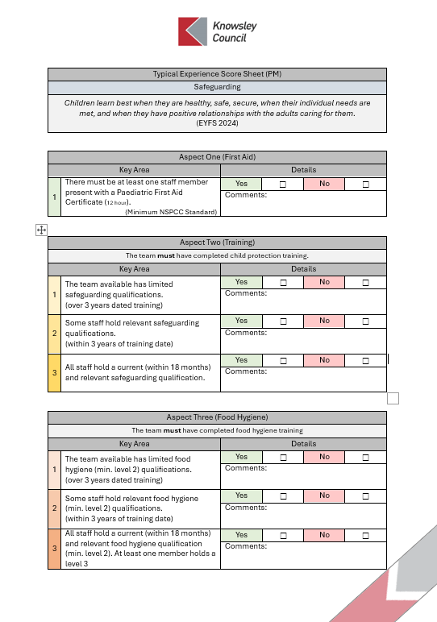
TESS
If you are finding yourself consistently highlighting 1s & 2s or have found that a change you have made has led to lower results; it may be time to consider changing aspects of the provision or even feeding these into supervisions to support CPD and access to Knowsley led courses e.g. Safeguarding Training
A simplified Yes | No format should allow for speed of completion.
The comments section is an opportunity to list evidence or a place to jot notes for ideas for future development.
Only tick Yes for one area 1|2|3 if this is evident in your practice/provision.
Don’t be afraid to grade low, be honest and use this as a starting point to push quality.
Don’t be afraid to grade high, if you have the evidence in practice this form can be used to support your Ofsted preparation.

Typical Experience Score Sheet (PM)
Voice of the Child
Every child has the right to express their views, feelings and wishes in all matters affecting them, and to have their views considered and taken seriously. This right applies at all times, for example during immigration proceedings, housing decisions or the child’s day-to-day home life.
(UNICEF 1989)

Experience One (Awareness)
Key Area |  | Details
1 | The team have limited to no knowledge of the concept of the ‘Voice of the Child’ | Yes | ☒ | No | ☐
1 |  | Comments:
2 | The team have some understanding of the ‘Voice of the Child’ but this is not commonly discussed or considered. | Yes | ☐ | No | ☐
2 |  | Comments:
3 | The team have a strong knowledge of the concept of the ‘Voice of the Child’ and how this applies to their practice and provision. | Yes | ☐ | No | ☐
3 |  | Comments:

Experience Two (Training)
Key Area |  | Details
1 | The team available has not completed training on the Voice of the Child.  (over 3 years dated training) | Yes | ☐ | No | ☐
1 |  | Comments:
2 | Some staff have completed Voice of the Child training.  (within 2 years of training date) | Yes | ☐ | No | ☐
2 |  | Comments:
3 | All staff have attended Voice of the Child training recently (within 18 months). | Yes | ☐ | No | ☐
3 |  | Comments:

Experience Three (Reflection)
Key Area |  | Details
1 | The team does not reflect on their commitment to hearing the ‘Voice of the Child’ | Yes | ☐ | No | ☐
1 |  | Comments:
2 | The team occasionally reflect on their commitment to hearing the ‘Voice of the Child’ but this is irregular | Yes | ☐ | No | ☐
2 |  | Comments:
3 | The ‘Voice of the Child’ has a central place in the team’s reflection and development cycle. | Yes | ☐ | No | ☐
3 |  | Comments:

Experience Four (Using Tools)
Key Area |  | Details
1 | The team do not utilise tools such as WellComm or SSTEW to review and improve their approach. | Yes | ☐ | No | ☐
1 |  | Comments:
2 | The team actively use rating tools to provide external insight into their approach to hearing the ‘Voice of the Child’ | Yes | ☐ | No | ☐
2 |  | Comments:

Experience Five (Subliminal Voice)
Key Area |  | Details
1 | The team are unaware of the subtle ways children present their voice, instead expecting children to vocally voice their opinions and feelings. | Yes | ☐ | No | ☐
1 |  | Comments:
2 | The team are aware of the subtle ways children present their voice, noticing and acting on aspects such as wellbeing, learning styles and schemas. | Yes | ☐ | No | ☐
2 |  | Comments:

Experience Six (Exes)
Key Area |  | Details
1 | The team are unaware of the EXE scale. The wellbeing and involvement of the children is not considered in decision making or planning. | Yes |  | ☐ |  | No |  | ☐
1 |  | Comments:
2 | Wellbeing and Involvement are considered and placed at the centre of the decision making and planning process (especially during transitions. | Yes |  | ☐ |  | No |  | ☐
2 |  | Comments:
Experience Seven (Impact of Individuality)
Key Area |  |  | Details
1 | Activities and spaces are predesigned with little to no consideration for the individual characteristics, schemas and learning styles of the children accessing them. |  | Yes |  | ☐ |  | No | ☐
1 |  |  | Comments:
2 | Spaces and activities reflect the unique characteristics, schemas and learning styles of the children accessing the provision. |  | Yes |  | ☐ |  | No | ☐
2 |  |  | Comments:

Experience Eight (Feedback)
Key Area |  | Details
1 | Children are rarely given the opportunity to talk about their provision and give feedback on the activities/spaces provided | Yes | ☐ | No | ☐
1 |  | Comments:
2 | Children are given regular opportunities to provide feedback on their provision in a plethora of different models | Yes | ☐ | No | ☐
2 |  | Comments:

Experience Nine (Families)
Key Area |  | Details
1 | There is limited engagement with families with little known about the child’s interests and needs at home. | Yes | ☐ | No | ☐
1 |  | Comments:
2 | Families are actively involved in the decision making processes. Parents are consulted regularly to provide insight into the child’s ‘voice’ at home including interests and family milestones. | Yes | ☐ | No | ☐
2 |  | Comments:

Experience Ten (Impact)
Key Area |  | Details
1 | Children are consulted but this is not then applied to the decision making process. Children do not have an influence on the Wraparound provision. | Yes | ☐ | No | ☐
1 |  | Comments:
2 | The team confidently present the impact child choice has had on their provision. They are able to demonstrate how they consult their children and the techniques they use to observe the ‘Voice of the Child’ | Yes | ☐ | No | ☐
2 |  | Comments:



