



Knowsley Wraparound

TESS Guide


Aspect 5
Resources

“Quality in education is what makes learning a pleasure and a joy”
- MYRON TRIBUS


The Typical
Experience
Score Sheets (TESS)

A Guide To
Grading Scale – designed to promote reflection on key areas of the provision.
Consider the 1|2|3 format as a ladder for demonstrating progression (e.g. you may grade Term One a 1 and by the start of Term Three you may grade yourself a 3)
As your provision starts to feel established or evolves over time you may naturally feel that you have progressed through the ‘Areas’.
You may notice as children/team members settle some indicators will improve.
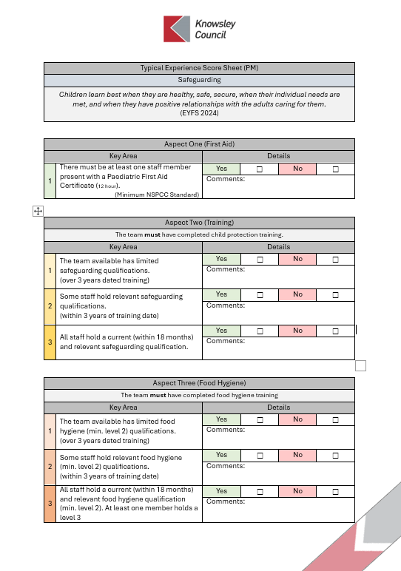
TESS
If you are finding yourself consistently highlighting 1s & 2s or have found that a change you have made has led to lower results; it may be time to consider changing aspects of the provision or even feeding these into supervisions to support CPD and access to Knowsley led courses e.g. Safeguarding Training
A simplified Yes | No format should allow for speed of completion.
The comments section is an opportunity to list evidence or a place to jot notes for ideas for future development.
Only tick Yes for one area 1|2|3 if this is evident in your practice/provision.
Don’t be afraid to grade low, be honest and use this as a starting point to push quality.
Don’t be afraid to grade high, if you have the evidence in practice this form can be used to support your Ofsted preparation.

Typical Experience Score Sheet (PM)
Resources
“Practitioners should be ambitious for all children. To do this they must consider the
individual needs, interests, and development of each child in their care. They must
use this information to plan a challenging and enjoyable experience for each child in
all areas of learning and development.”
(Early Years Foundation Stage, 2024)

Experience One (Awareness)
Key Area |  | Details
1 | The team have limited to no knowledge of the impact of the resources available in the Wraparound provision. | Yes | ☐ | No | ☐
1 |  | Comments:
2 | The team have some understanding of the impact of the resources made available during Wraparound care but this is not commonly discussed or considered. | Yes | ☐ | No | ☐
2 |  | Comments:
3 | The team have a strong knowledge of the value of a high quality Wraparound resources and can present this confidently | Yes | ☐ | No | ☐
3 |  | Comments:

Experience Two (Training)
Key Area |  | Details
1 | The team available has not completed training on Wraparound resources.  (over 3 years dated training) | Yes | ☐ | No | ☐
1 |  | Comments:
2 | Some staff have completed the Wraparound resources training.  (within 2 years of training date) | Yes | ☐ | No | ☐
2 |  | Comments:
3 | All staff have attended the Wraparound resources training recently (within 18 months). | Yes | ☐ | No | ☐
3 |  | Comments:

Experience Three (Reviewing Resources)
Key Area |  | Details
1 | There is little consideration to the suitability of resources provided. Reviews of the resources on offer are irregular and linear, ignoring the opportunities for external insight. | Yes | ☐ | No | ☐
1 |  | Comments:
2 | The team utilise a wide array of tools to regularly review the resources on offer, including the voice of the child in decision making. | Yes | ☐ | No | ☐
2 |  | Comments:

Experience Four (Updating Resources)
Key Area |  | Details
1 | Resources do not change over time with the team unsure of how to adapt and change the resources to meet the needs of new children, cohorts, seasons or topics. | Yes | ☐ | No | ☐
1 |  | Comments:
2 | The resources are refreshed regularly, changing and adapting to the needs of each child accessing the provision. A wide variety of concepts, topics and aspects of the curriculum are reflected in the provision. | Yes | ☐ | No | ☐
2 |  | Comments:

Experience Five (Child Centred Approach)
Key Area |  | Details
1 | Children are rarely given the opportunity to present interests or projects which would influence the resources on offer. | Yes | ☐ | No | ☐
1 |  | Comments:
2 | Children are consulted but this is not then applied to the decision making process when choosing what resources to make available. | Yes | ☐ | No | ☐
2 |  | Comments:
3 | Children are at the centre of the decision making process. Children are actively consulted and underlying aspects of child ‘voice’ are considered when planning available resources. | Yes | ☐ | No | ☐
3 |  | Comments:

Experience Six (Deeper Level Considerations)
Key Area |  | Details
1 | The team are unaware of the subtle ways children demonstrate the suitability of resources instead focusing on vocal opinions. | Yes | ☐ | No | ☐
1 |  | Comments:
2 | The underlying learning styles, characteristics and schemas of individual children are considered when planning the resources made available.  The team understand their children on a deeper level and prioritise wellbeing and involvement when planning the resources to make available. | Yes | ☐ | No | ☐
2 |  | Comments:

Experience Seven (The Outdoor Experience)
Key Area |  | Details
1 | There are limited resources made available in the outdoor space. The resources made available do not reflect the quality of the indoor provision, missing opportunities to extend concepts and ideas into the outdoor space. The team do not display confidence in how to adapt resources into the outdoor space. | Yes | ☐ | No | ☐
1 |  | Comments:
2 | The resources made available outside are an extension of the indoor provision but with a focus on the potential of the natural world as an extension of key aspects of the curriculum. The team provide resources which not only interact with the natural world but help children to make connections to previously learnt concepts such as weight, size and measurement. The team confidently engage with resources in the outdoor provision and understand what makes these opportunities unique compared to the indoor environment. | Yes | ☐ | No | ☐
2 |  | Comments:

Experience Eight (Connection To The Curriculum)
Key Area |  | Details
1 | The Wraparound provision is considered separate to the typical provision. The purpose of the resources on offer do not link to the settings ethos and curriculum. | Yes | ☐ | No | ☐
1 |  | Comments:
2 | The Wraparound provision is a clear extension of the providers curriculum. The team actively link the resources on offer to elements of the curriculum allowing children to progress their learning and interests naturally. | Yes | ☐ | No | ☐
2 |  | Comments:

Experience Nine (Resource Diversity)
Key Area |  | Details
1 | The Wraparound provision focuses too heavily on one aspect of the curriculum missing opportunities to diversify their offer and engage children with different learning styles or needs e.g. only sports activities on offer when some children may need a quieter/unwind space. | Yes | ☐ | No | ☐
1 |  | Comments:
2 | The Wraparound provision provides a diverse range of resources, carefully planned to support the wellbeing and involvement of all children accessing. | Yes | ☐ | No | ☐
2 |  | Comments:

Experience Ten (Age/Stage Differentiation)
Key Area |  | Details
1 | The is no differentiation for children of different ages or stages of development. The team are unaware of the different resource needs of children dependent on their age/stage of development. | Yes | ☐ | No | ☐
1 |  | Comments:
2 | The resources on offer reflect the diverse range of the ages/stages of development of the children accessing the provision. The team confidently support children to progress from one stage of resource onto more challenging but appropriate resources. | Yes | ☐ | No | ☐
2 |  | Comments:

Experience Eleven (Sustainability)
Key Area |  | Details
1 | There is little to no consideration for the impact of the resources used. The team and children are unaware of the impact of disposable resources on their provision and the wider world. | Yes | ☐ | No | ☐
1 |  | Comments:
2 | The team consider the impact of the resources and equipment on the environment. Sustainability is at the centre of planning process with children actively aware of their impact. | Yes | ☐ | No | ☐
2 |  | Comments:



