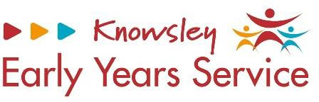

Transitions To Settings – All About Me
People who will be collecting me are | My daily routine is | Milk you are on  How many Oz do you have What times are your bottles
Food I like  Food I dislike | I like to sleep on  My comfort is or are | My likes  My dislikes
My health visitor is | Any other professionals involved | Any allergies or medical conditions

