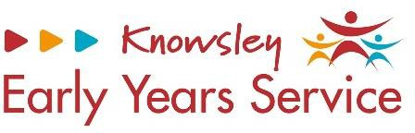

Transition to Setting Form – Interests
My favourite things to play with at home are? |  | My favourite places I like to visit are? |  | My favourite objects to play with around the house are?
e.g. cars, dolls, Lego, colouring in, musical toys etc. |  | e.g. parks, farms, museums, beach etc. |  | e.g. pots, pans, mirrors, brushes, plant pots etc.
My favourite characters are? |  | My favourite nursery rhymes and songs are? |  | My favourite messy play activities are?
e.g. Peppa Pig, Fire Man Sam, Sofia the First etc. |  | e.g. Twinkle Twinkle, Old Macdonald, Wind My Bobbin Up etc. |  | e.g. play dough, gloop, water, mud etc.
Things I would like support with are? |  | The people I really enjoy playing with are? |  | Any other information you would  like to share with us to improve your child’s learning
e.g. toilet training, talking, making relationships, using a knife and fork etc. |  | e.g. mum, dad, nan, grandad, siblings, friends etc.
Parents Signature: |  |  | Key Person Signature:
Date: |  |  | Date:

