




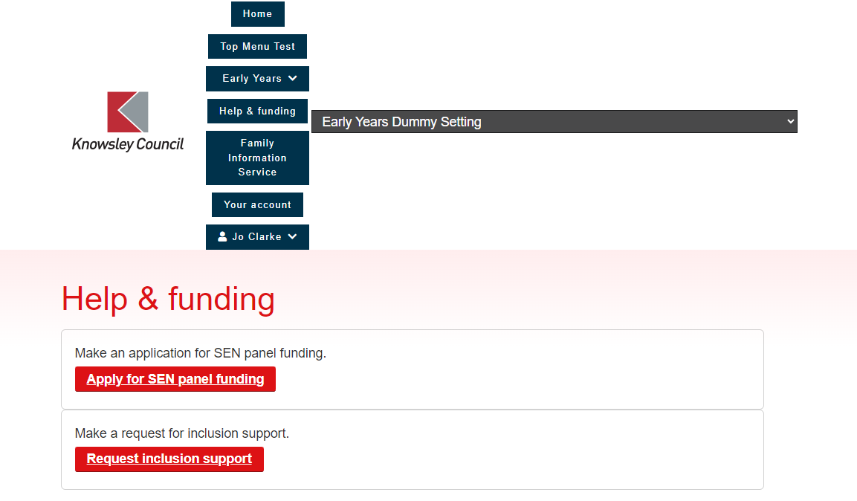


YOU MUST ATTACH A SIGNED PARENTAL PERMISSION FORM OR THE REQUEST WILL BE DECLINED Parental Permission Form | Knowsley Info

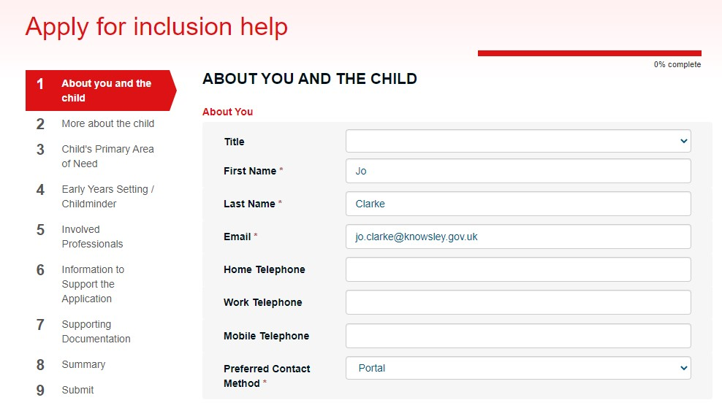
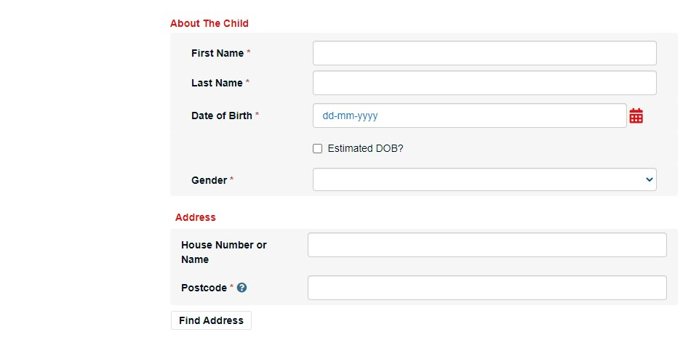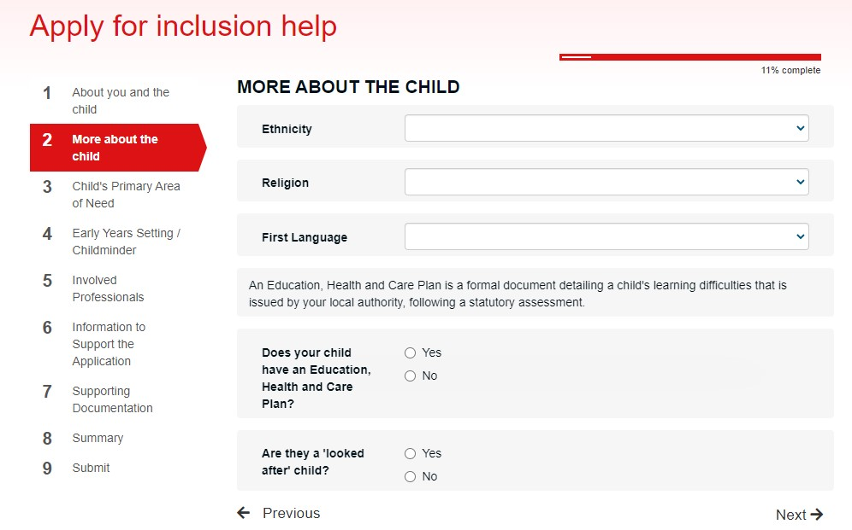
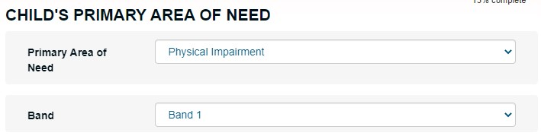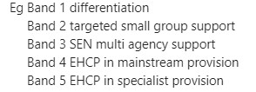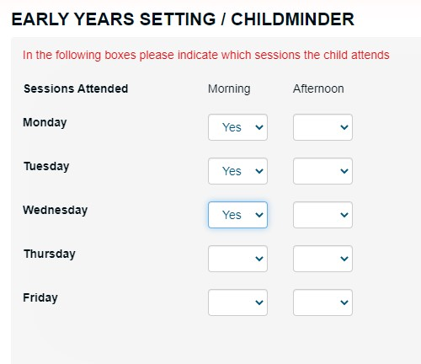
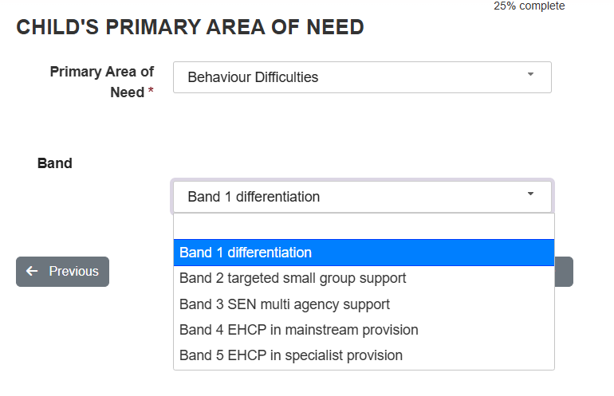Click on next

Select the days and sessions the child attends. If the sessions don’t fit into this format, please add this on to the additional information section at the end of the form.

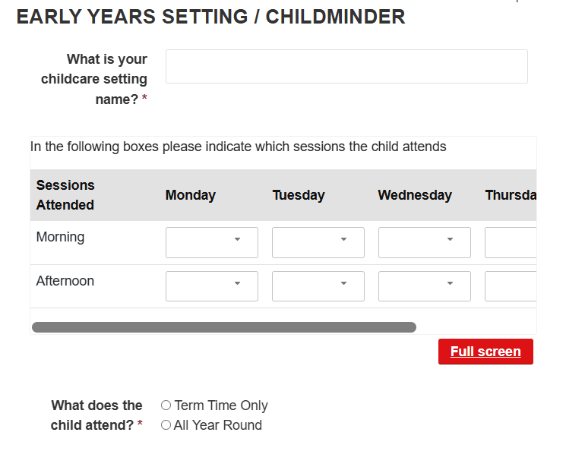
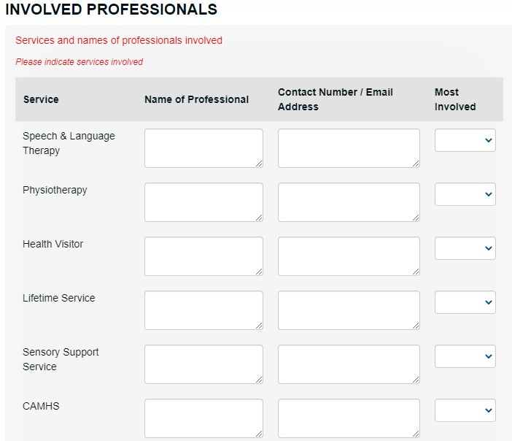
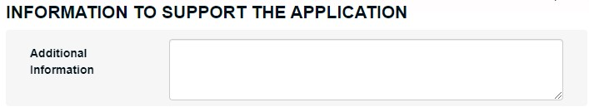
- Outline of child’s needs
- Where you are up to on the graduated response
- Whether a differentiation action plan has been actioned and updated o Does the child have a play plan in place? What are the main targets on this plan
- Named support person in setting o Named setting senco

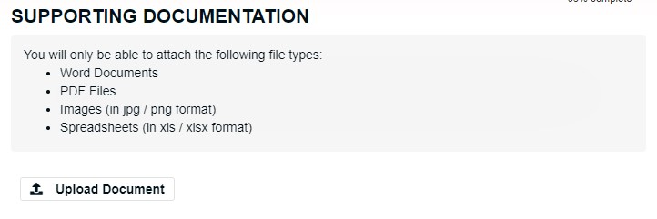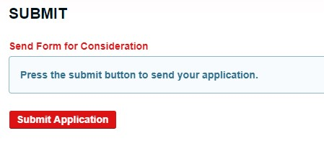
PLEASE NOTE: YOU MUST ATTACH A PARENTAL PERMISSION FORM OR THE APPLICATION WILL BE DECLINED Parental Permission Form | Knowsley Info
