1 OCTOBER 2021 CIRCULAR – BLACK HISTORY MONTH.
1 OCTOBER – NATIONAL POETRY DAY
Poetry is for everyone!
Why not encourage our EAL learners to write their favourite poems in their home language and share with their peers? Follow the link below for ideas and inspiration. Feel free to share any poems with us too and we can include them in our newsletter at the end of the month.
https://nationalpoetryday.co.uk/celebrate-national-poetry-day/
BLACK HISTORY MONTH
www.bbc.co.uk/news/uk-england-merseyside-54387940.
This link draws attention to a stone that has been put in place commemorating Liverpool’s first black resident ‘Abbel’ born 1-10-1717.
The link also draws on a brief history of Liverpool and the Slave Trade.
See below for ‘Famous, Black and Scouse’
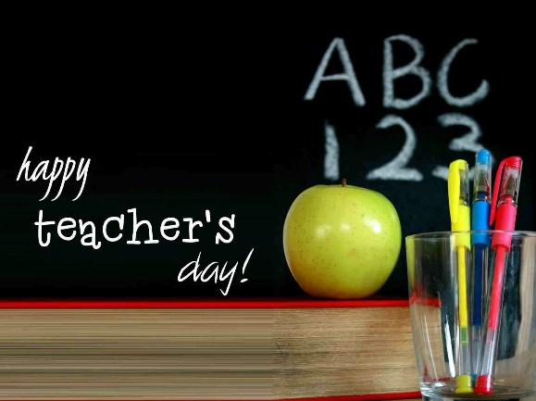
5 OCTOBER 2021 – WORLD TEACHERS DAY
World Teachers' Day 2021 - Event Info and Resources (twinkl.co.uk) - this website has excellent ideas in how to celebrate this day.
This year has the theme of the impact that teacher’s have had during the pandemic. This theme can be explored with all ages.
From the above website here are some fun facts about teachers –
- After doctors and nurses, teachers are the third most trusted profession in the UK.
- In the UK alone, there are over half a million teachers. Around 216,500 work in primary schools.
- Britain's oldest teacher is believed to be Irene Basham. Since 1947, the 92 year-old has taught young children at Farfield Primary School in Bradford, West Yorkshire.
- There are over 10 million pupils in the UK in both full time and part-time education. This demonstrates the enormous demand for teachers and the role they play in shaping the future.

1 OCTOBER 2021 BLACK HISTORY MONTH
Teachers of both Primary and Secondary students please see the link below for
A wide range of activities to do during Black History Month.
www.bbc.co.uk/teach/black-history-month-primary-and-secondary
Primary
The site looks at the life and works of Rosa Parks, Harriet Tubman, Pablo Fanque, Mary Seacole,
Florence Price and Joseph Bolgne.

Secondary
The site covers the following areas as well as much more.
Immigration to London from Ghana and Jamaica.
Britain’s forgotten slave owners.
Stephen Lawrence – the murder that changed a nation.
Nelson Mandela – Freedom fighter, South Africa first black president
American Civil War
The origins of blues and ragtime music
Horrible Histories


Famous Black and Scouse

Irene Afful

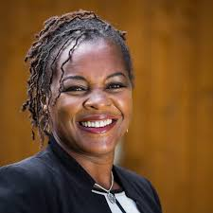
When Irene Afful was growing up in L8 in the 1970s and 1980s, relations between Merseyside Police and the city's black community were not in a good place. Despite tensions within her community and a fear of police, Irene went on to join the force herself. Irene Afful was the first black female inspector in Merseyside Police history. Quickly rising through the ranks, Irene became Merseyside Police's first ever female black inspector, breaking down racial and gender boundaries to get to become such a trailblazer for other black women. Irene left Merseyside Police 4 years ago and now runs her own coaching and personal development company aimed at showing others how to emulate her success.

Gee Walker

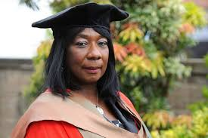
In 2005, Anthony Walker was murdered in a horrific and unprovoked racist attack. His senseless death left his family devastated but in the face of unimaginable grief and loss, his mother chose to use her experiences to try and help others and vowed to fight against hate crime and she set up the Anthony Walker Foundation. The charity aims to promote racial harmony through education, sport and the arts and operates across the UK. As well as hosting an annual community festival, the charity also provides a bursary for students from poorer backgrounds to study law. Gee's work was commended by Prime Minister David Cameron in 2016, who applauded her work to combat racism.

Howard Gayle

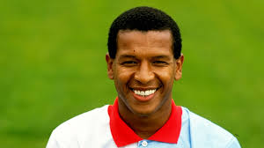
Born in Toxteth in1958, Howard Gayle was the first black footballer to play for Liverpool F.C. He joined the youth ranks at local side Liverpool in 1974 and signed a professional contract with the club in 1977. He was seen as a trailblazer in a sport that was almost all white at the time. His finest hour for Liverpool came in the 1980-81 European Cup semi-final second leg, away at Bayern Munich. Since retiring from football, he has become an anti-racism campaigner and has worked with ‘Kick It Out’ and ‘Show racism the red card’.
James Clarke

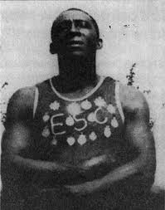
James Clarke was an incredible man and a legend in Liverpool. James saved many locals from drowning in the Mersey and the docks and taught countless others to swim. James Clarke James was born in British Guiana (now Guyana). When he was 14, he stowed away on a ship bound for Liverpool and was adopted by an Irish family living in the Scotland Road
area. James worked on the docks and joined Wavertree Swimming Club. He started teaching children to swim after rescuing many of them from the Leeds and Liverpool Canal. James was the first black man to have a street named after him, his silver chain with eight medals awarded to him for swimming and 'saving life from drowning'. You can see some of James’ medals and a framed certificate ‘Liverpool Shipwreck and Humane Society, awarded to James Clarke for courageously diving into the West Waterloo Dock and rescuing a man from drowning on the 14th of February 1911’ on display in The People’s Republic gallery, Museum of Liverpool.

Anna Rothery

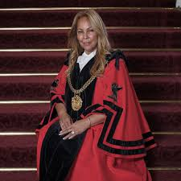
Anna Rothery was the first black Lord Mayor in the history of Liverpool. Anna was born and grew up in the Toxteth area. In 2006, she represented the Princes Park ward in the Parliamentary constituency of Liverpool Riverside. As a councillor she supported the Black and Minority Ethnic community and became involved in activities including, ‘Operation Black Vote’ - a scheme to get more people with the BAME background into politics. From 2010–2013, she became Chair of the Culture, Tourism and Sport select committee in Liverpool. Then in 2012 she became the first councillor of Liverpool to speak at the United Nations in Geneva on Religious, Linguistic and Cultural differences. In September 2019, Anna became the first black Lord Mayor in the history of the city of Liverpool. She was also named the UK’s most influential black politician at the National Baton Awards 2019; she was overwhelmed and humbled by the honour. Anna said, ‘I’m a working class woman brought up in Toxteth – where you come from should never stop you striving or achieving your goals’.

KS3 TASKS
- Students to pick one of the above and research more in depth their life history.
- Students to research any other famous Liverpool born black and why they have had an impact. They are to present their findings in the form of a newspaper article.
KS2 – Assembly
Teacher to present the above in a PowerPoint and talk about them.

